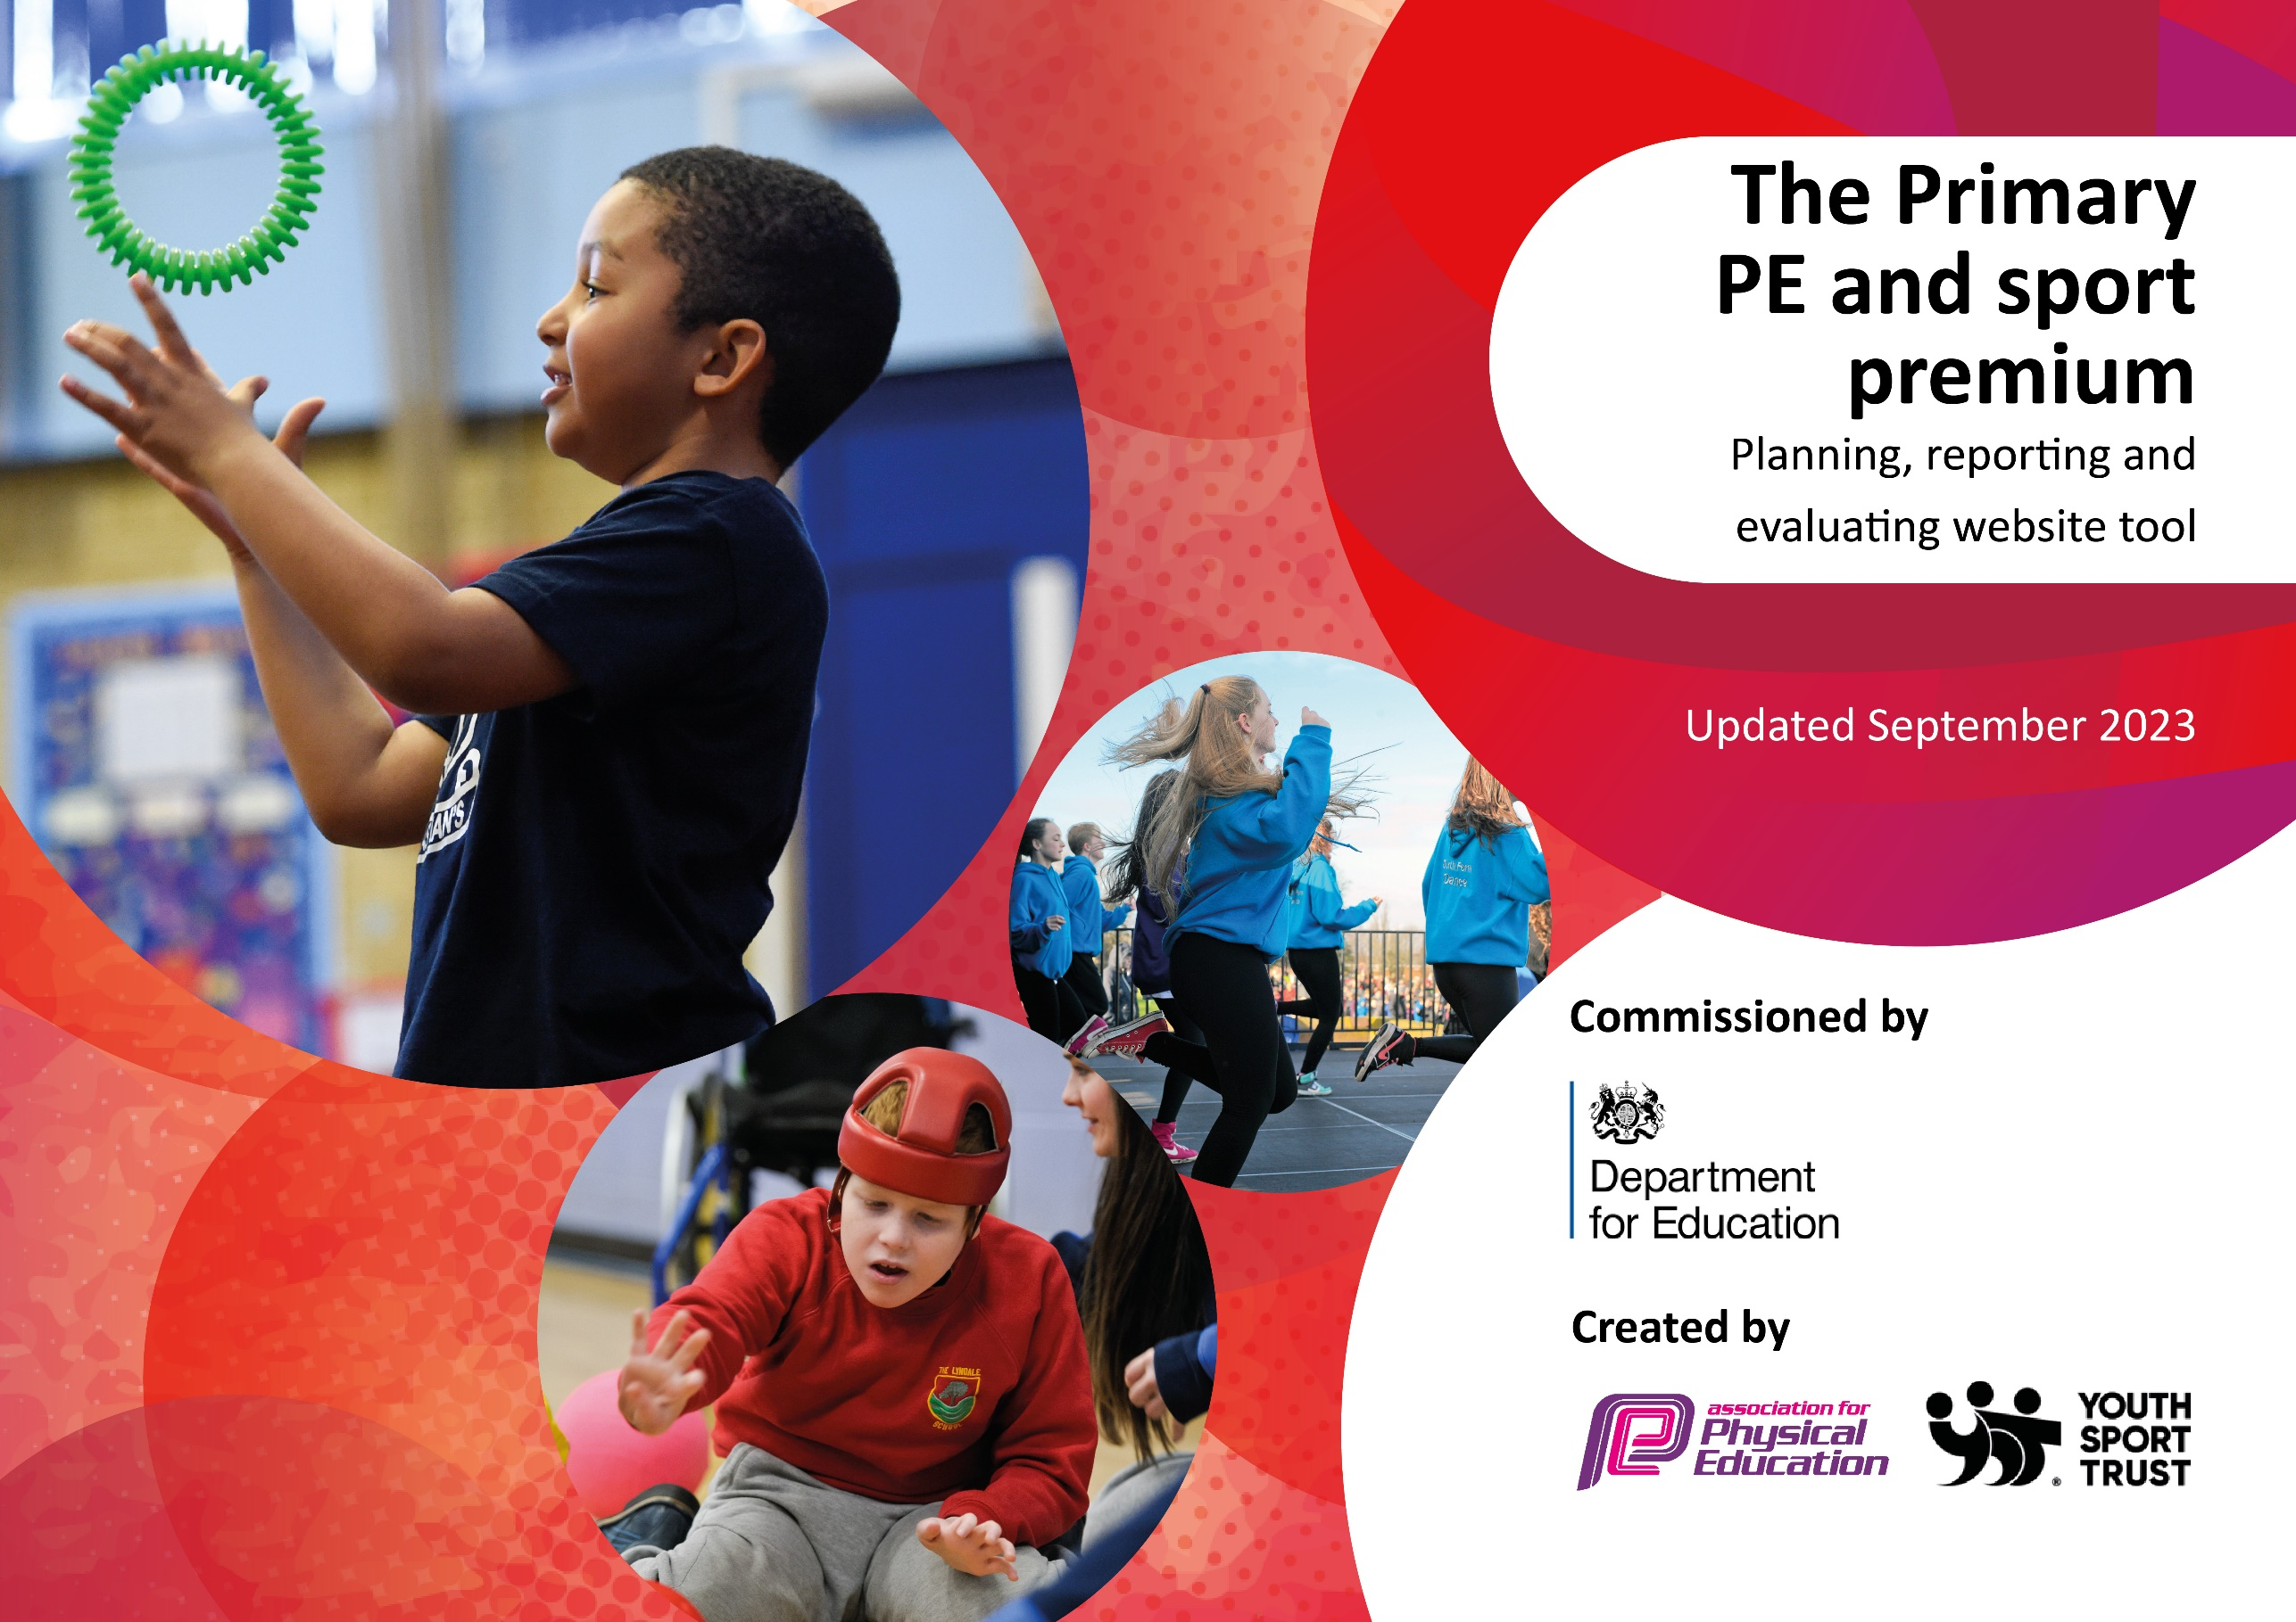

Review of last year’s spend and key achievements (2023/2024)

We recommend you start by reflecting on the impact of current provision and reviewing your previous spend.

Activity/Action | Impact | Comments
All groups in KS2 were able to have swimming lessons  SSCO role funded with CPD and supply.  Commando Jo Programme | Increased water confidence and safety for pupils.  Over 20 competitions offered to pupils during the year ranging from Reception to Year 6.  Increased enjoyment of team activities and creative play outside. Focus on teamwork, resilience and mental health saw pupils highly engaged and looking forward to sessions. | An essential lynchpin of our offer to ensure disadvantaged pupils particularly have basic swimming skills.  A regular offer of competitive sports in and outside school maintain the importance and profile of physical activity.  Regular access to outdoor learning structured and linked to the curriculum providing challenge and resilience beyond traditional sports and games.

Key priorities and Planning
This planning template will allow schools to accurately plan their spending.

Action – what are you planning to do | Who does this action impact? | Key indicator to meet | Impacts and how sustainability will be achieved? | Cost linked to the action
Introduce Outdoor Learning program for lunchtimes OPAL. | Lunchtime supervisors / teaching staff, coaches - as they need to lead the activity  pupils – as they will take part. | Key indicator 2 -The engagement of all pupils in regular physical activity – the Chief Medical Officer guidelines recommend that all children and young people aged 5 to 18 engage in at least 60 minutes of physical activity per day, of which 30 minutes should be in school.  Key indicator 4: Broader experience of a range of sports and activities offered to all pupils. | More pupils meeting their daily physical activity goal, more pupils encouraged to take part in PE and Sport Activities.  Improved behavior and engagement in activities. | £5000 costs for additional coaches to support lunchtime sessions.

Introduce the Real PE curriculum and other CPD for teachers.  Provide swimming lessons for an additional 120 pupils with a SEND focus and non-swimmer intensive programme.  Provide transport for pupils to sporting events and attend events during the school day including supply for staff and SSCO to attend.  Employ a dedicated SSCO responsible for organizing and managing competitions and events  Commando Jo programme in place and used as part of the wider curriculum and to supplement existing outdoor learning and PE opportunities. | Primary generalist teachers.  Pupils  Pupils, families and parents  Pupils, Staff  Pupils and Staff | Key Indicator 1: Increased confidence, knowledge, and skills of all staff in teaching PE and sport.  Key indicator 5: Increased participation in competitive sport.  Key indicator 2 -The engagement of all pupils in regular physical activity – the Chief Medical Officer guidelines recommend that all children and young people aged 5 to 18 engage in at least 60 minutes of physical activity per day, of which 30 minutes should be in school.  Key indicator 4: Broader experience of a range of sports and activities offered to all pupils.  Key indicator 2 -The engagement of all pupils in regular physical activity – the Chief Medical Officer guidelines recommend that all children and young people aged 5 to 18 engage in at least 60 minutes of physical activity per day, of which 30 minutes should be in school.  Key indicator 4: Broader experience of a range of sports and activities offered to all pupils.  Key indicator 4: Broader experience of a range of sports and activities offered to all pupils.  Key indicator 4: Broader experience of a range of sports and activities offered to all pupils. | Primary teachers more confident to deliver effective PE supporting pupils to undertake extra activities inside and outside of school, including teaching water safety and swimming and as a result improved % of pupil’s attainment in PE.  More pupils able to swim and stay safe in water. Higher engagement in swimming galas and competitive events. Lower risk of death by drowning.  Barriers to participation removed for pupils from lower income families and families without transport or multiple siblings.  More pupils meeting their daily physical activity goal, more pupils encouraged to take part in PE and Sport Activities.  More pupils meeting their daily physical activity goal, more pupils encouraged to take part in PE and Sport Activities. | £1000 for all teachers to undertake REAL PE CPD and top up training. The PE coordinator and SSCO to attend relevant PE related and school sport CPD throughout the year including briefings, conferences and specific level 2 and 3 training where required.  £500 for REAL PE subscription to platform and resources.  £7000 for hire of pool, staff, lifeguards and energy to run the programme.  £1500  £1200  £2000

Key achievements 2024-2025
This template will be completed at the end of the academic year and will showcase the key achievements schools have made with their Primary PE and sport premium spending.

Activity/Action | Impact | Comments
TBC 2025 | TBC 2025 | TBC 2025

Swimming Data
Meeting National Curriculum requirements for swimming and water safety.
Priority should always be given to ensuring that pupils can perform safe self-rescue even if they do not fully meet the first two requirements of the National Curriculum programme of study

Question | Stats: | Further context  Relative to local challenges
What percentage of your current Year 6 cohort can swim competently, confidently and proficiently over a distance of at least 25 metres? | 71% | High proportion of non-swimmers from a mostly disadvantaged background and several pupils with SEND or physical limitations which impacted their confidence in water and the family’s ability to get them to swim throughout their lives. All of these pupils participated and improved in sessions although for some they took a while to adjust and gained confidence slowly in the water.
What percentage of your current Year 6 cohort can use a range of strokes effectively [for example, front crawl, backstroke, and breaststroke]? | 65% | The percentage of non-swimmers affected their ability to master a range of strokes in time but we feel our offer of swimming over multiple years will improve this over time. In 3 years, we anticipate this to be far higher.

What percentage of your current Year 6 cohort are able to perform safe self-rescue in different water-based situations? | 80% | Pupils were able to perform basic floats without aids and support themselves in water.
If your schools swimming data is below national expectation, you can choose to use the Primary PE and sport premium to provide additional top-up sessions for those pupils that did not meet National Curriculum  requirements after the completion of core lessons. Have you done this? | Yes | We have a swimming pool erected on site and provide swimming lessons for Years 2-6 including specific SEND friendly sessions and non-swimmer classes as well as after school clubs at a cost of £7000.
Have you provided CPD to improve the knowledge and confidence of staff to be able to teach swimming and water safety? | No | We hire specialists to deliver our sessions and maintain safety and high quality teaching.

Signed off by:

Head Teacher: | Andrew Reeves
Subject Leader or the individual responsible for the Primary PE and sport premium: | Dave Steer
Governor: | Kieran Bennett
Date: | 27/07/2024

