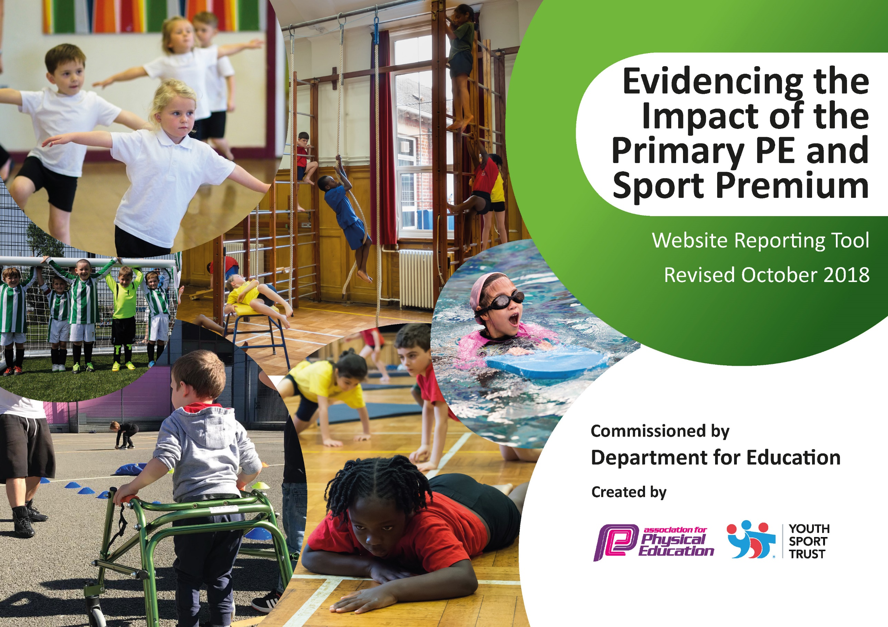
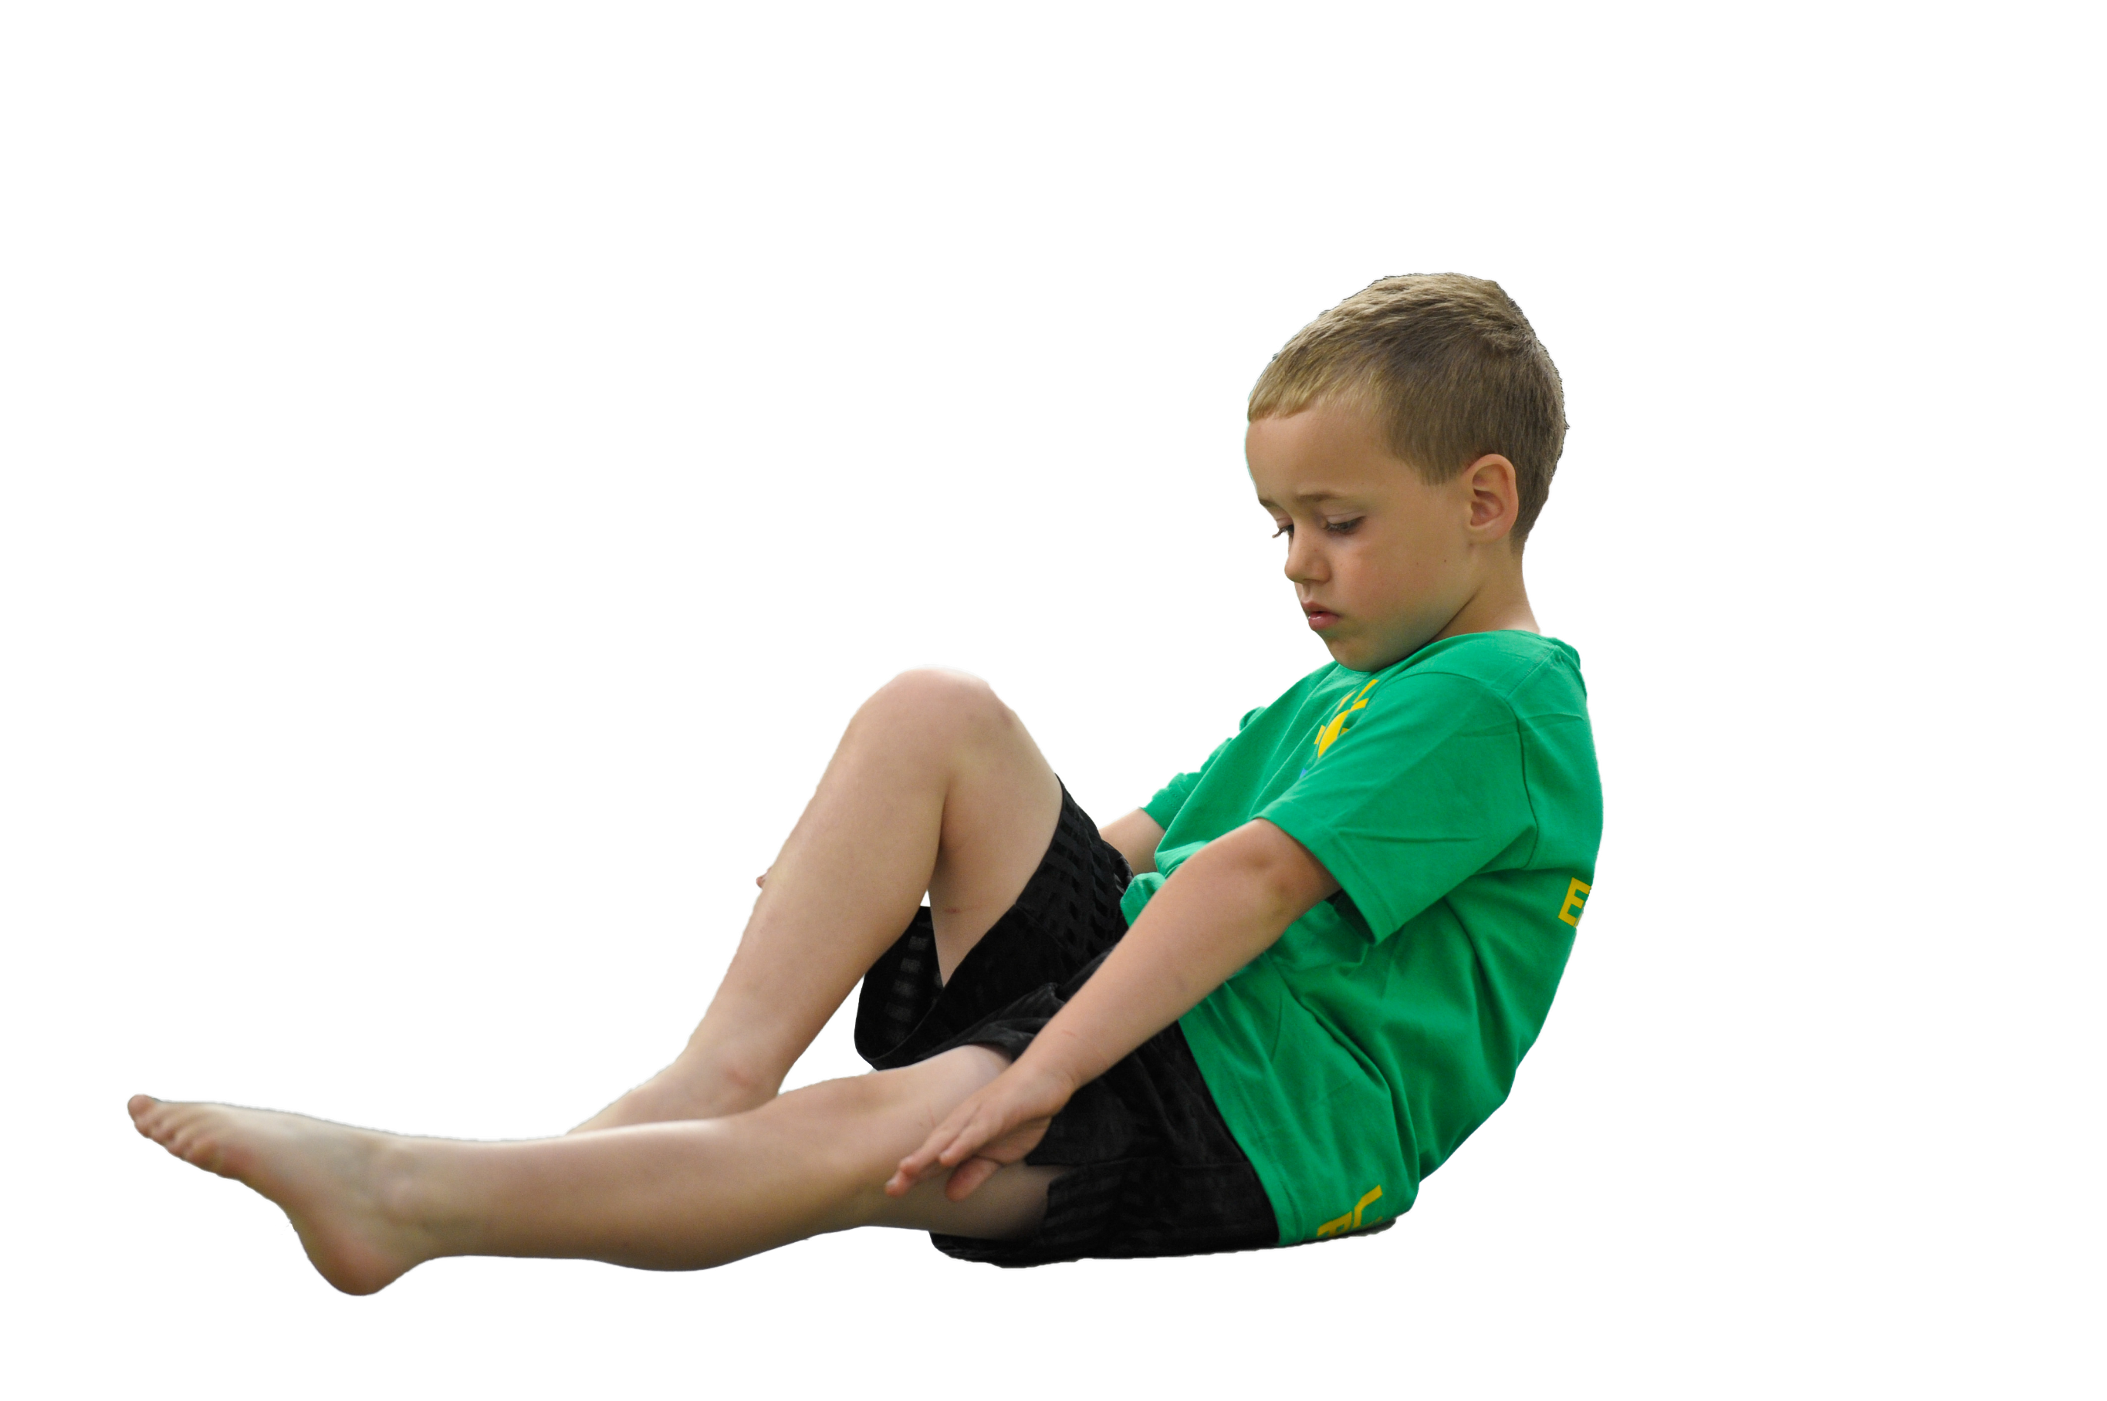
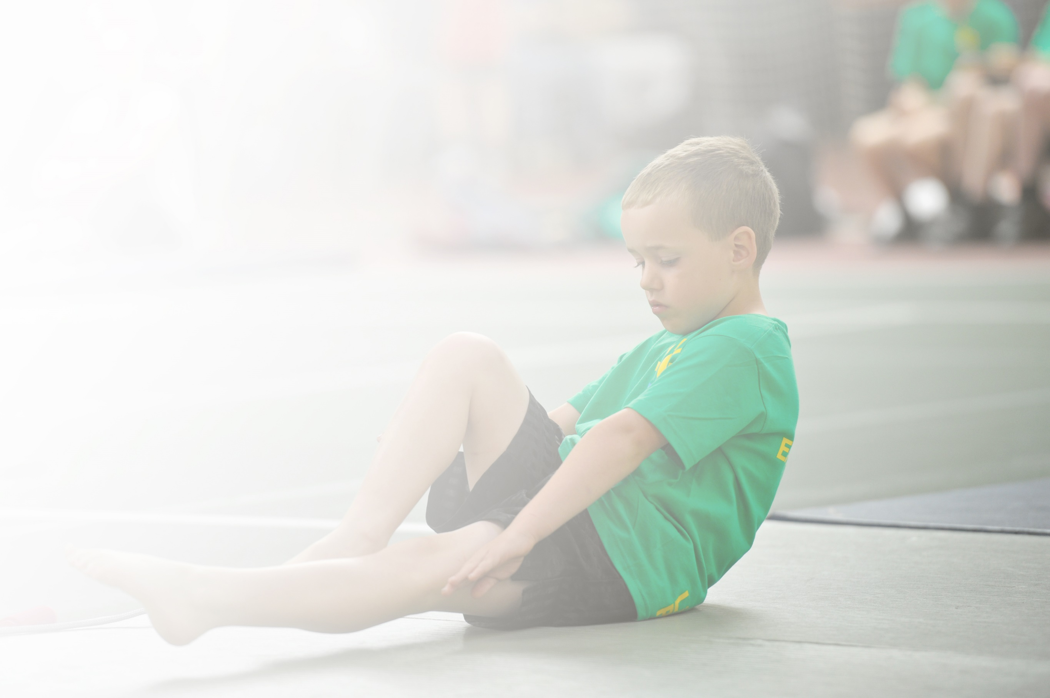
Schools must use the funding to make additional and sustainable improvements to the quality of Physical Education, Sport and Physical Activity (PESPA) they offer. This means that you should use the Primary PE and Sport Premium to:

- Develop or add to the PESPA activities that your school already offer
- Build capacity and capability within the school to ensure that improvements made now will benefit pupils joining the school in future years

Please visit gov.uk for the revised DfE guidance including the 5 key indicators across which schools should demonstrate an improvement. This document will help you to review your provision and to report
Your spend. DfE encourages schools to use this template as an effective way of meeting the reporting requirements of the Primary PE and Sport Premium.

We recommend you start by reflecting on the impact of current provision and reviewing the previous
spend. Under the Ofsted Schools Inspection Framework, inspectors will assess how effectively leaders use the Primary PE and Sport Premium and measure its impact on outcomes for pupils, and how effectively governors hold them to account for this.

Schools are required to publish details of how they spend this funding as well as on the impact it has on pupils’ PE and sport participation and attainment by the end of the summer term or by 31 July 2019 at the
latest.
We recommend regularly updating the table and publishing it
on your website throughout the year, as evidence of your
ongoing review into how you are using the money to
secure maximum, sustainable impact. To see an
example of how to complete the table please
click HERE.

Support for review and reflection - considering the 5 key indicators from DfE, what development needs are a priority for your setting and your students now and why? Use the space below to reflect on previous spend, identify current need and priorities for the future.

Key achievements to date: | Areas for further improvement and baseline evidence of need:
- Earning the Platinum Sportsmark  - Increased participation in school sport  - A wider offer of sports than ever  - Increasingly confident staff capable of quality PE delivery.  - An award for Participation in Sport during Lockdown  - Staff Member of the Year Award 2019  - Platinum Active School Award 2019 | Interactive online competitions  Increased performance in remote competition due to Covid 19  Earning the Sportsmark for remote competition.

Meeting national curriculum requirements for swimming and water safety | Please complete all of the below:
What percentage of your current Year 6 cohort swim competently, confidently and proficiently over a distance of at least 25 metres?  N.B. Even though your children may swim in another year please report on their attainment on leaving  Primary school. | Unknown – Swimming suspended due to Covid.
What percentage of your current Year 6 cohort use a range of strokes effectively [for example, front crawl, backstroke and breaststroke)? | Unknown – Swimming suspended due to Covid.
What percentage of your current Year 6 cohort perform safe self-rescue in different water-based situations? | Unknown – Swimming suspended due to Covid.
Schools can choose to use the Primary PE and Sport Premium to provide additional provision for swimming but this must be for activity over and above the national curriculum requirements. Have you used it in this way? | Unknown – Swimming suspended due to Covid.

Action Plan and Budget Tracking
Capture your intended annual spend against the 5 key indicators. Clarify the success criteria and evidence of impact that you intend to measure to evaluate for students today and for the future.

Academic Year: 2021/2022 | Total fund allocated: £18473 | Date Updated:31/7/2021
Key indicator 1: The engagement of all pupils in regular physical activity – Chief Medical Officer guidelines recommend that primary school children undertake at least 30 minutes of physical activity a day in school |  |  |  | Percentage of total allocation:
 |  |  |  | £4500 19%
School focus with clarity on intended impact on pupils: | Actions to achieve: | Funding allocated: | Evidence and impact: | Sustainability and suggested next steps:
All pupils take part in 30-60 minutes of physical activity per day, with greater numbers enjoying active sessions. | - Equipment out at breaks and lunch  - Participation Monitored by Active Leader  - Maintain role of Play Leader at lunchtime  - Increase in equipment to minimise sharing | Play Leader £3500  Equipment £1000 | Busy lunchtimes with pupils engaged in play  Equipment used and respected at lunchtimes  Pupils active and enjoying time outside. | Investing in resources with an annual budget  Training opportunities for Play Leader  Protect Active Time on timetable
Key indicator 2: The profile of PESSPA being raised across the school as a tool for whole school improvement |  |  |  | Percentage of total allocation:
 |  |  |  | £1600 5%
School focus with clarity on intended impact on pupils: | Actions to achieve: | Funding allocated: | Evidence and impact: | Sustainability and suggested next steps:
To make athlete/sportsperson visits commonplace and inspirational including greater links with Derbyshire Sport and sponsoring athletes who are then connected to school. Celebrating sport in the newsletter and on social media. Awards in collective worships and external coaches raising the standard and profile of after school sport. | - Audit sports resources and purchase new  - Devise and revise the action plan  - Run lunchtime clubs to enhance sporting opportunity  - Focus on staff rotas and organisation  - Post Sports Events and Active Day to Website and Facebook/Newsletter | Derbyshire Sport: £1500  Active Co-ordinator: £500 | Photographs  Pupil Interviews | Fund this each year and maintain visits.  Vary sporting links to improve interest in lesser known sports.  Maintain high profile associated with sporting participation throughout school.

Key indicator 3: Increased confidence, knowledge and skills of all staff in teaching PE and sport |  |  |  | Percentage of total allocation:
 |  |  |  | £2000 10%
School focus with clarity on intended  impact on pupils: | Actions to achieve: | Funding  allocated: | Evidence and impact: | Sustainability and suggested  next steps:
CPD for ALL staff | - New staff and PE coordinator access relevant training | £2000 | Lesson Observations  Participation and Enjoyment  Pupil Interviews  Staff Surveys | Timetable sporting CPD onto Inset calendar and improve knowledge through annual skills audit.
Key indicator 4: Broader experience of a range of sports and activities offered to all pupils |  |  |  | Percentage of total allocation:
 |  |  |  | £2000 10%
School focus with clarity on intended  impact on pupils: | Actions to achieve: | Funding  allocated: | Evidence and impact: | Sustainability and suggested  next steps:
100% take up on ASP sports offers and other opportunities such as triathlon.  Widening opportunities through virtual events and PE lessons based on lesser known sports. | - Engage Coaches virtually or in person when RA permits at no, reduced cost or free to parents online  - Coaches used in curriculum time online  - Active Leader uses Squad in touch to run programme of sports  - Devices used to monitor sporting opportunities and link events to SSP | ASP Affiliation: £1600  CQ PE SCHEME: £400 | Participation  PE assessments show improved skills  Pupil Interviews and Staff surveys  Performance improvements at events.  Tracker shows 100% participation. | Maintain profile of sport through CCW, newsletter, social media and vary opportunities by manufacturing these where external events are not available. E.g. online tournaments, in house competitions.
Key indicator 5: Increased participation in competitive sport |  |  |  | Percentage of total allocation:
 |  |  |  | £7000 56%
School focus with clarity on intended  impact on pupils: | Actions to achieve: | Funding  allocated: | Evidence and impact: | Sustainability and suggested  next steps:
Monitor and include as many pupils as can be in competitive intra and inter school sport.  Transport and kit to reduce barriers.  Supply cover for staff to support events occurring in school day.  Technology used to improve access to online activities. | - Purchase shin pads, kit Etc to allow 100% participation.  - Active Leader to monitor school for participation patterns.  - IPads to analyse performance and improve coaching | Resources and transports to ensure a share of equipment and opportunity for all pupils: £3000  Technology: £4000 | Use of technology in PE and at sport competitions including wider opportunities and to access online competitions.  Resources enable access to sport with minimal sharing to reduce transmission of Covid 19. | Maintain profile of sport through CCW, newsletter, social media and vary opportunities by manufacturing these where external events are not available. E.g. online tournaments, in house competitions.

