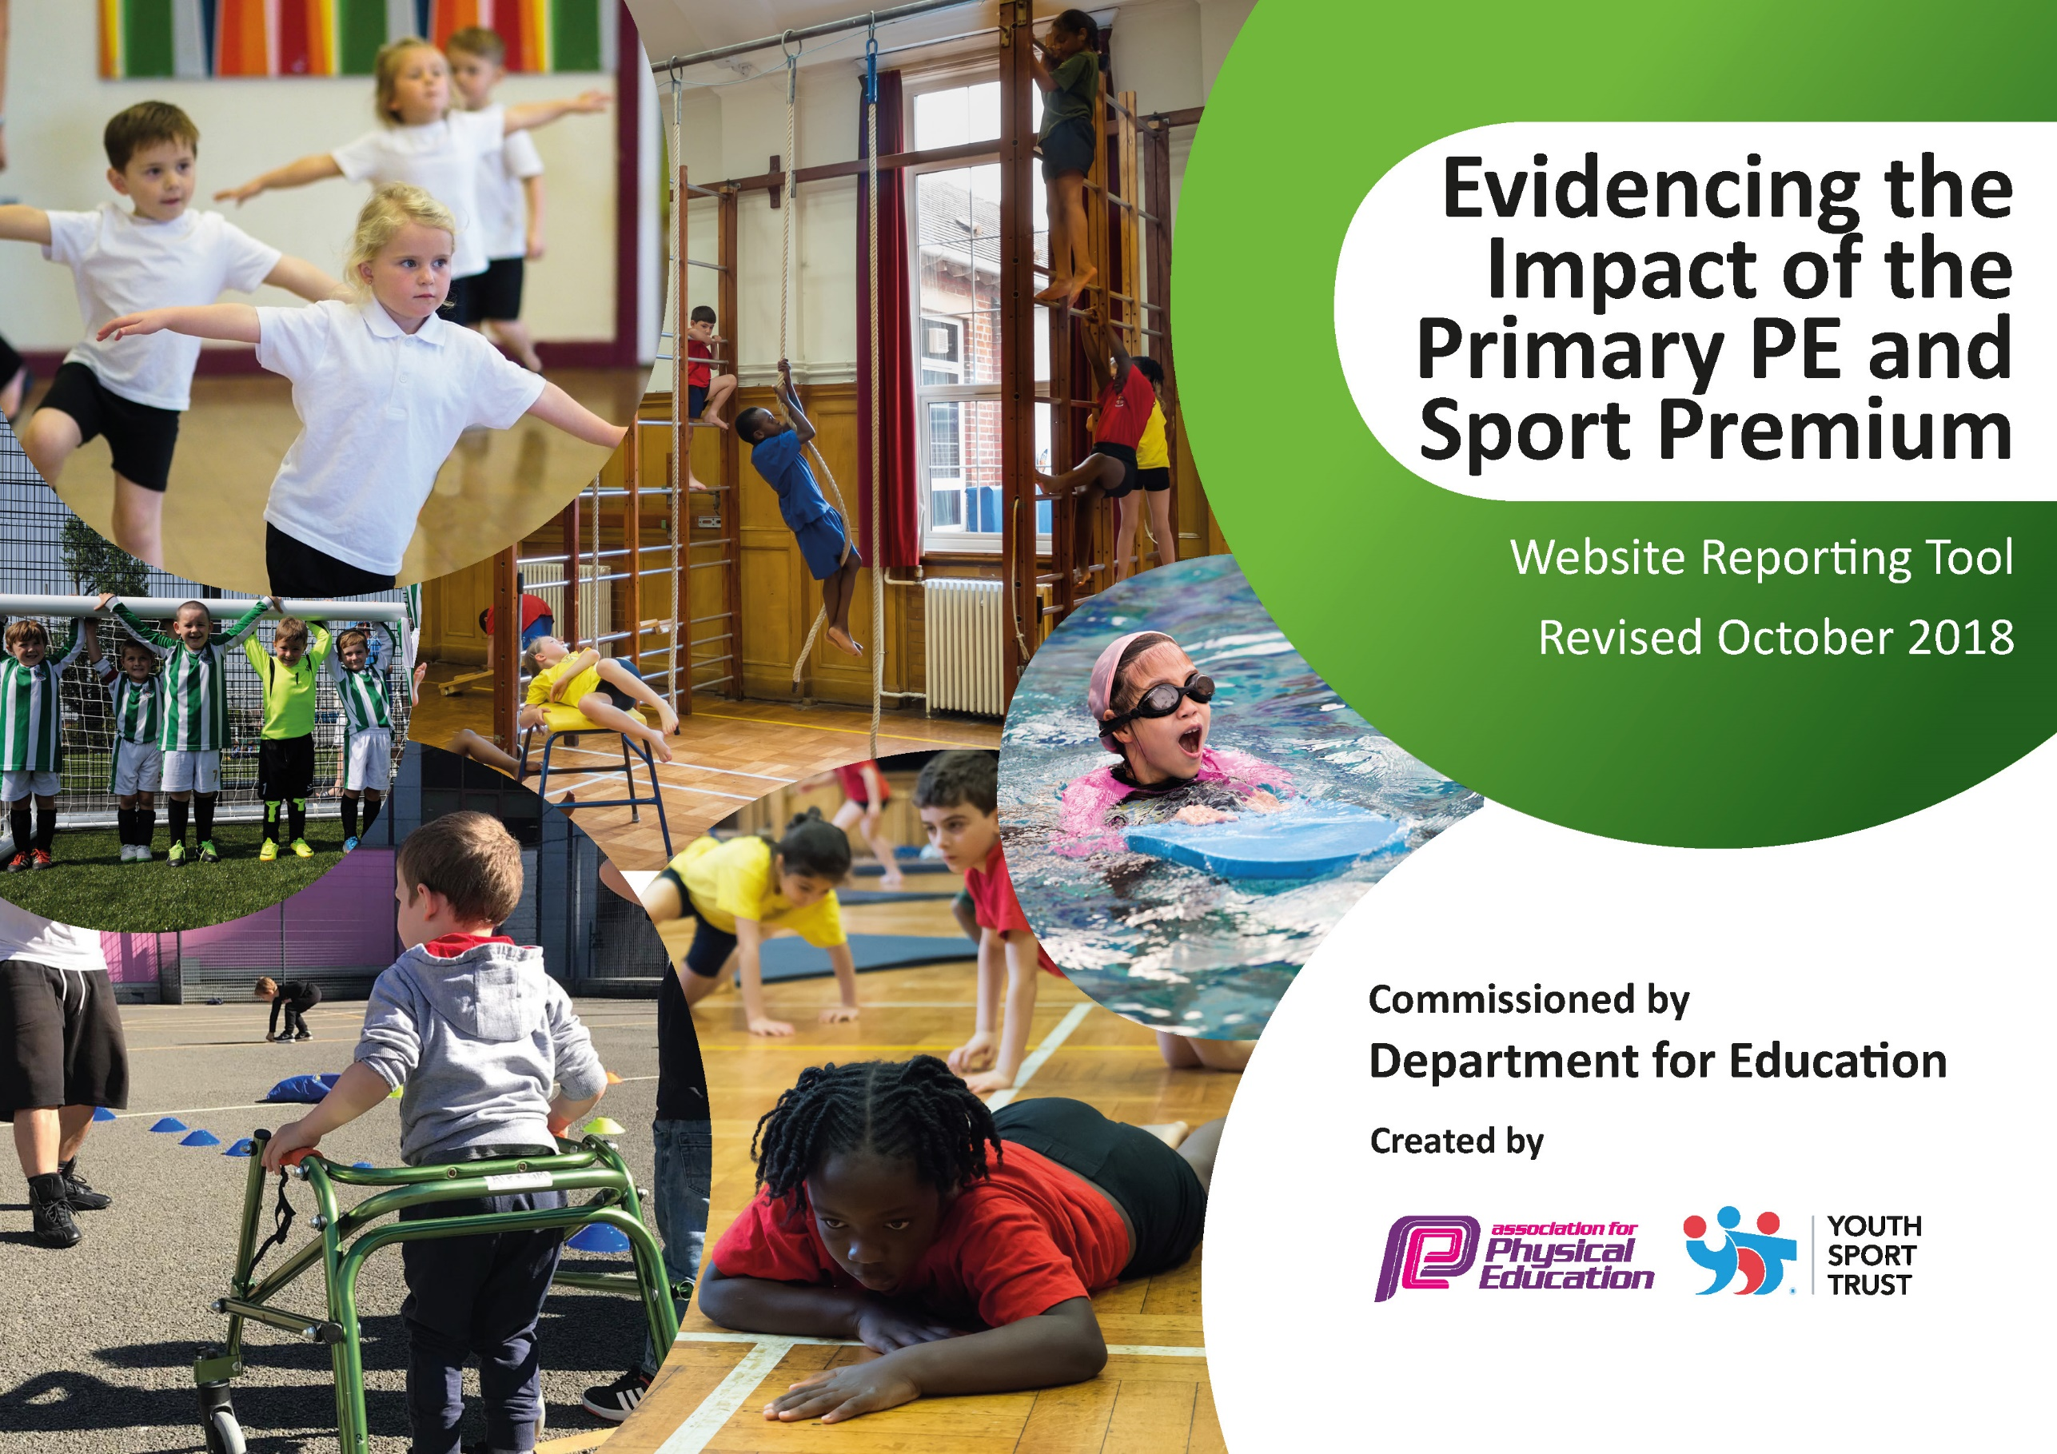
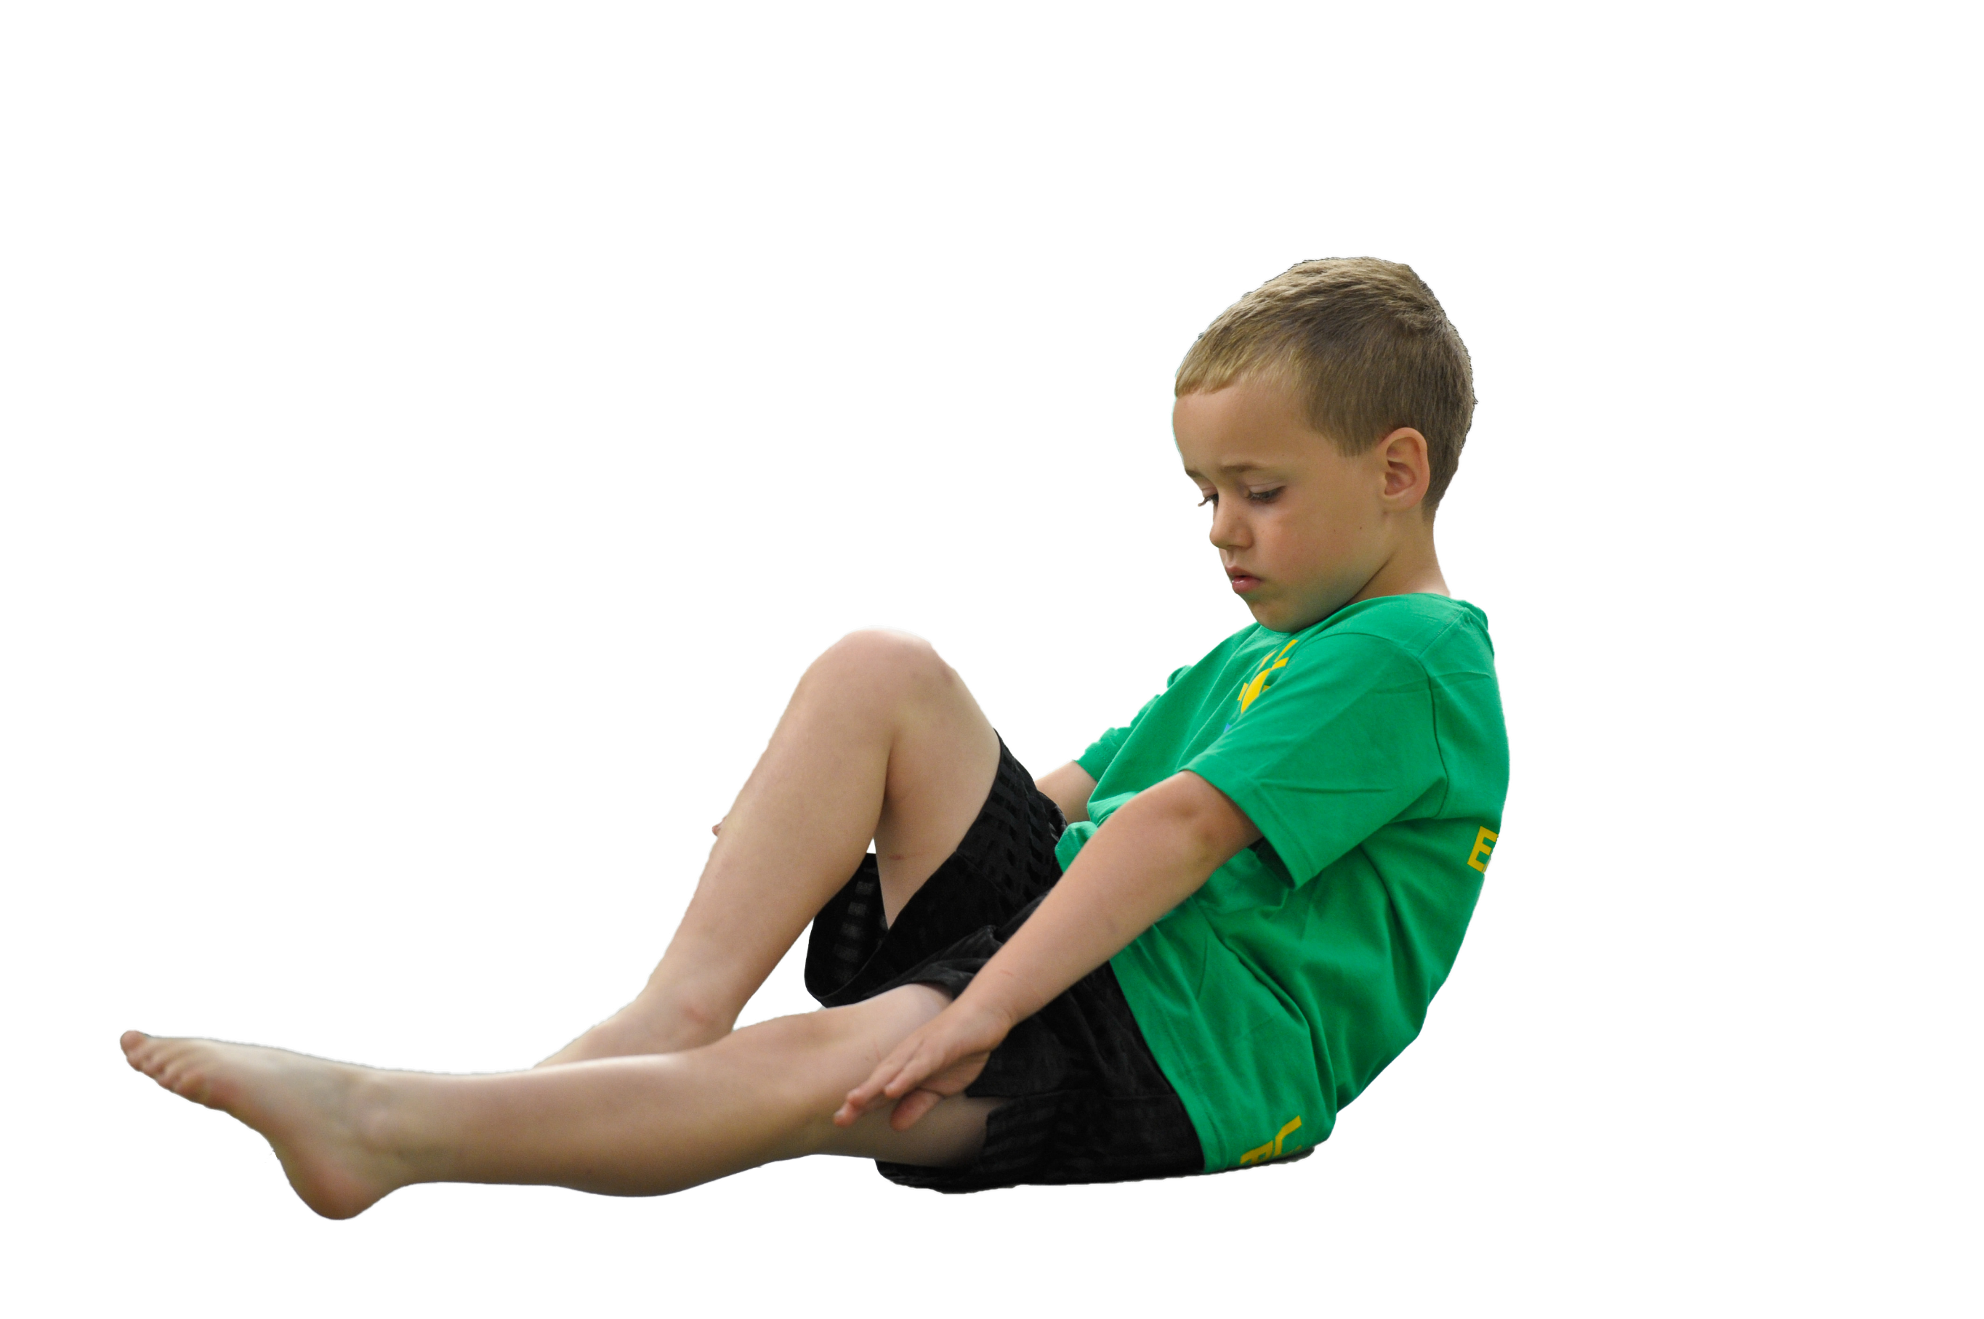
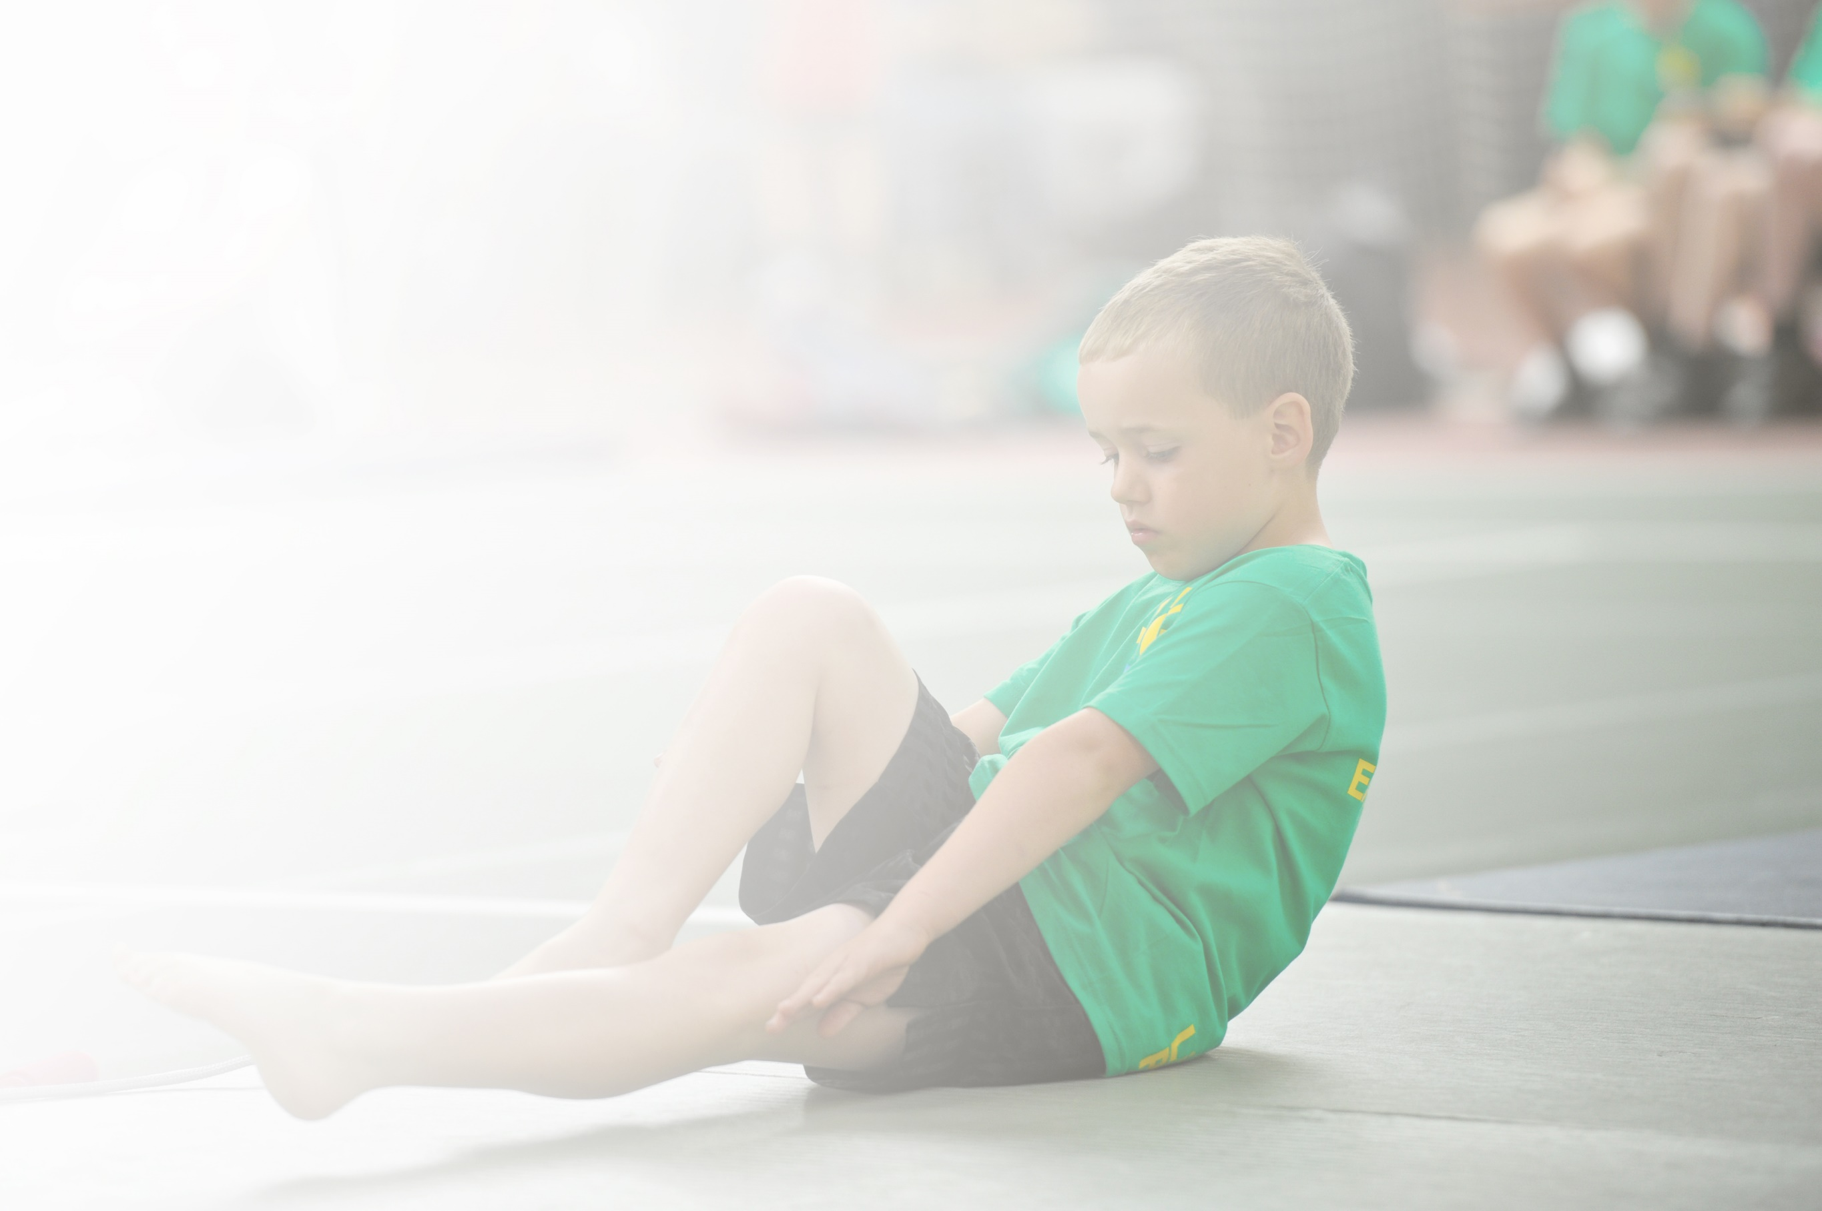
Schools must use the funding to make additional and sustainable improvements to the quality of Physical Education, Sport and Physical Activity (PESPA) they offer. This means that you should use the Primary PE and Sport Premium to:

- Develop or add to the PESPA activities that your school already offer
- Build capacity and capability within the school to ensure that improvements made now will benefit pupils joining the school in future years

Please visit gov.uk for the revised DfE guidance including the 5 key indicators across which schools should demonstrate an improvement. This document will help you to review your provision and to report
Your spend. DfE encourages schools to use this template as an effective way of meeting the reporting requirements of the Primary PE and Sport Premium.

We recommend you start by reflecting on the impact of current provision and reviewing the previous
spend. Under the Ofsted Schools Inspection Framework, inspectors will assess how effectively leaders use the Primary PE and Sport Premium and measure its impact on outcomes for pupils, and how effectively governors hold them to account for this.

Schools are required to publish details of how they spend this funding as well as on the impact it has on pupils’ PE and sport participation and attainment by the end of the summer term or by 31 July 2019 at the
latest.
We recommend regularly updating the table and publishing it
on your website throughout the year, as evidence of your
ongoing review into how you are using the money to
secure maximum, sustainable impact. To see an
example of how to complete the table please
click HERE.

Support for review and reflection - considering the 5 key indicators from DfE, what development needs are a priority for your setting and your students now and why? Use the space below to reflect on previous spend, identify current need and priorities for the future.

Key achievements to date: | Areas for further improvement and baseline evidence of need:
- Earning the Platinum Sportsmark  - Increased participation in school sport  - A wider offer of sports than ever  - Increasingly confident staff capable of quality PE delivery. | Accessibility to sport and pathways into clubs.  Strengthened links to local clubs.  Identifying GT pupils earlier and guiding them to clubs.

Meeting national curriculum requirements for swimming and water safety | Please complete all of the below:
What percentage of your current Year 6 cohort swim competently, confidently and proficiently over a distance of at least 25 metres?  N.B. Even though your children may swim in another year please report on their attainment on leaving  Primary school. | 87%
What percentage of your current Year 6 cohort use a range of strokes effectively [for example, front crawl, backstroke and breaststroke]? | 77%
What percentage of your current Year 6 cohort perform safe self-rescue in different water-based situations? | 94%
Schools can choose to use the Primary PE and Sport Premium to provide additional provision for swimming but this must be for activity over and above the national curriculum requirements. Have you used it in this way? | Yes/No

Action Plan and Budget Tracking
Capture your intended annual spend against the 5 key indicators. Clarify the success criteria and evidence of impact that you intend to measure to evaluate for students today and for the future.

Academic Year: 2019/20 | Total fund allocated: £18000 | Date Updated:20/9/19
Key indicator 1: The engagement of all pupils in regular physical activity – Chief Medical Officer guidelines recommend that primary school children undertake at least 30 minutes of physical activity a day in school |  |  |  | Percentage of total allocation:
 |  |  |  | £4500 25 %
School focus with clarity on intended impact on pupils: | Actions to achieve: | Funding allocated: | Evidence and impact: | Sustainability and suggested next steps:
All pupils take part in 30-60 minutes of physical activity per day, with greater numbers enjoying preschool active sessions. | - Equipment out at breaks and lunch  - Clubs on offer at lunchtime  - Staff lead morning activities every day  - Participation Monitored by Active Leader  - Maintain role of Play Leader at lunchtime | Lunchtime Clubs: £2000  Play Leader £2500 | To be reviewed in October.
Key indicator 2: The profile of PESSPA being raised across the school as a tool for whole school improvement |  |  |  | Percentage of total allocation:
 |  |  |  | £4500 25%
School focus with clarity on intended impact on pupils: | Actions to achieve: | Funding allocated: | Evidence and impact: | Sustainability and suggested next steps:
To make athlete/sportsperson visits commonplace and inspirational including greater links with Derbyshire Sport and sponsoring athletes who are then connected to school. Celebrating sport in the newsletter and on social media. Awards in collective worships and external coaches raising the standard and profile of after school sport. | - Audit sports resources and purchase new  - Devise and revise the action plan  - Run lunchtime clubs  - Focus on staff rotas and organisation  - Post Sports Events and Active Day to Website and Facebook/Newsletter  - Invite athletes into school and maintain sponsorship of Derbyshire Sports. | Coaches: £3500  Derbyshire Sport: £500  Active Co-ordinator: £500 | To be reviewed in October.

Key indicator 3: Increased confidence, knowledge and skills of all staff in teaching PE and sport |  |  |  | Percentage of total allocation:
 |  |  |  | £3400 19%
School focus with clarity on intended  impact on pupils: | Actions to achieve: | Funding  allocated: | Evidence and impact: | Sustainability and suggested  next steps:
CPD for ALL staff  Real PE | - New staff and PE coordinator access relevant training | ASP Training: £1500  Real PE £1900 | To be reviewed in October.
Key indicator 4: Broader experience of a range of sports and activities offered to all pupils |  |  |  | Percentage of total allocation:
 |  |  |  | £1900 11%
School focus with clarity on intended  impact on pupils: | Actions to achieve: | Funding  allocated: | Evidence and impact: | Sustainability and suggested  next steps:
Golf Taster Day  Kickboxing Taster Day  Football Taster Day  External clubs run by coaches  100% take up on ASP sports offers and other opportunities such as triathlon. | - Engage Coaches at no reduced cost or free to parents  - Coaches used in curriculum time  - Active Leader uses Squad in touch to run programme of sports | ASP Affiliation: £1900 | To be reviewed in October.
Key indicator 5: Increased participation in competitive sport |  |  |  | Percentage of total allocation:
 |  |  |  | 3800 20%
School focus with clarity on intended  impact on pupils: | Actions to achieve: | Funding  allocated: | Evidence and impact: | Sustainability and suggested  next steps:
Monitor and include as many pupils as can be in competitive intra and inter school sport.  Transport and kit to reduce barriers.  Supply cover for staff to support events occurring in school day. | - Book transport  - Purchase shin pads, kit Etc to allow 100% participation.  - Active Leader to monitor school for participation patterns. | Coaches and Transport: £2000  Kit: £300  Cover: £1500 | To be reviewed in October.

