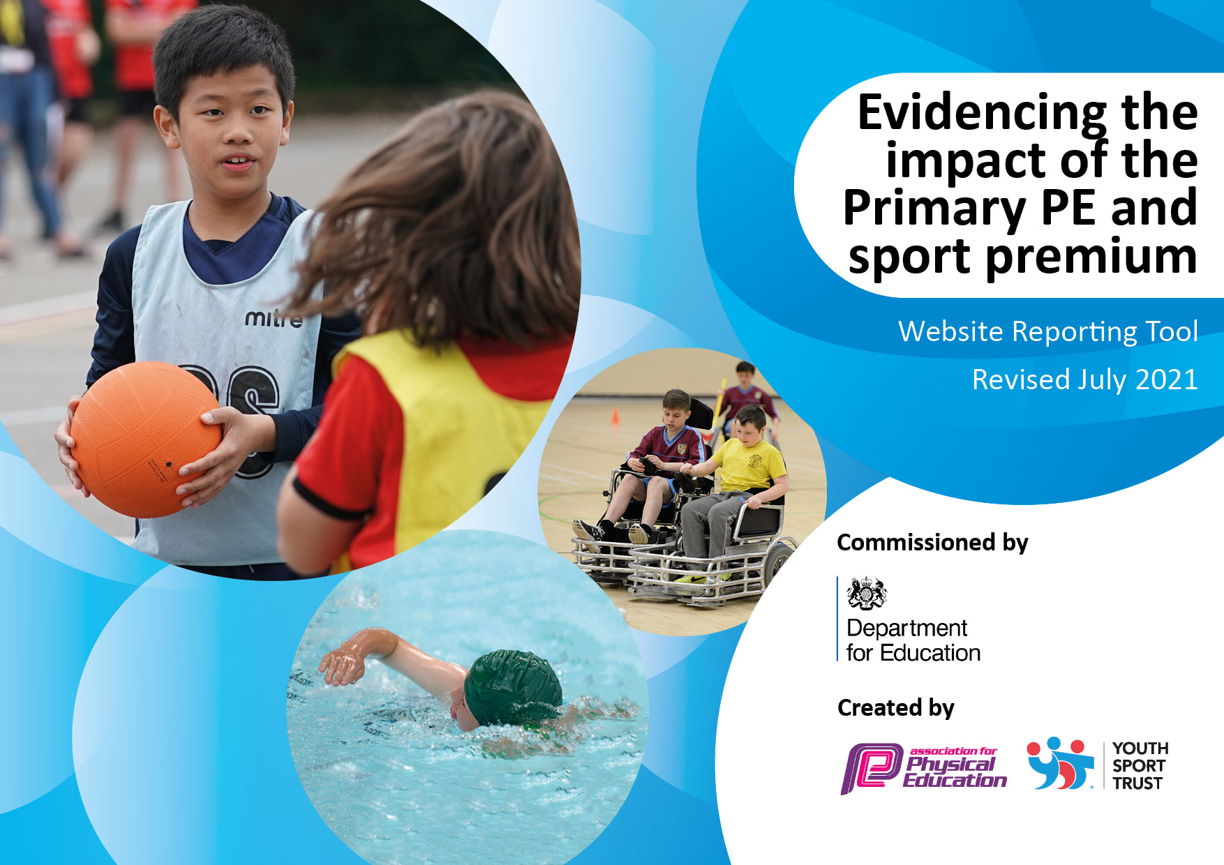
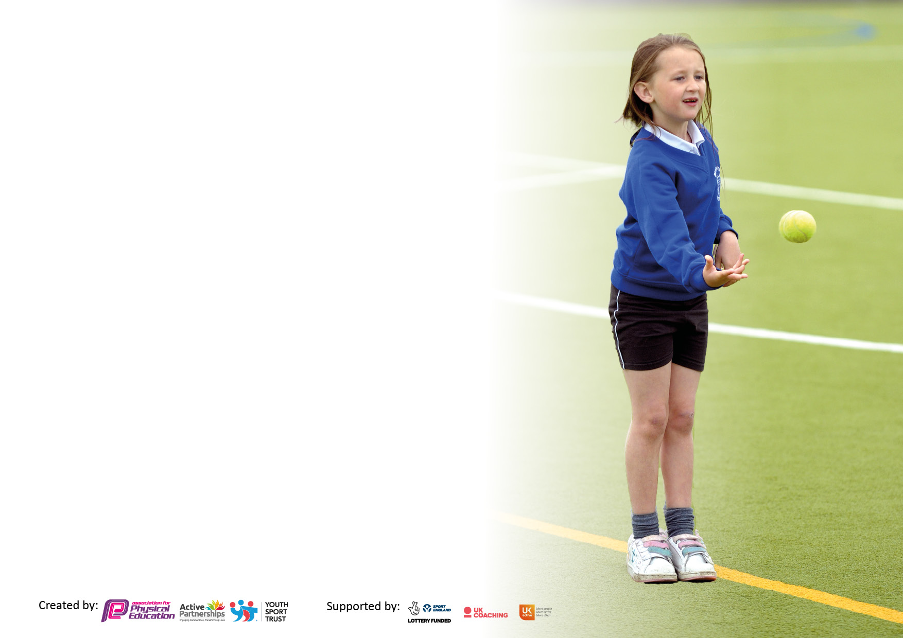

It is important that your grant is used effectively and based on school need. The Education Inspection Framework makes clear there will be a focus on ‘whether leaders and those responsible for governors all understand their respective roles and perform these in a way that enhances the effectiveness of the school’.

Under the Quality of Education Ofsted inspectors consider:
Intent - Curriculum design, coverage and appropriateness
Implementation - Curriculum delivery, Teaching (pedagogy) and Assessment
Impact - Attainment and progress

To assist schools with common transferable language this template has been developed to utilise the same three headings which should make your plans easily transferable between working documents.

Schools must use the funding to make additional and sustainable improvements to the quality of Physical Education, School Sport and Physical Activity (PESSPA) they offer. This means that you should use the Primary PE and sport premium to:

- Develop or add to the PESSPA activities that your school already offer
- Build capacity and capability within the school to ensure that improvements made now will benefit pupils joining the school in future years
- The Primary PE and sport premium should not be used to fund capital spend projects; the school’s budget should fund these.

Pleasevisitgov.ukfortherevisedDfEguidanceincludingthe5keyindicatorsacrosswhichschoolsshoulddemonstrate an improvement. This document will help you t o review your provision and to report your spend. DfE encourages schools to use this template as an effective way of meeting the reporting requirements of the Primary PE and sport premium.

We recommend you start by reflecting on the impact of current provision and reviewing the previous spend.

Schools are required to publish details of how they spend this funding, including any under-spend from 2019/2020, as well as on the impact it has on pupils’ PE and sport participation and attainment. All funding must be spent by 31st July 2022.

We recommend regularly updating the table and publishing it on your website throughout the year. This evidences your ongoing self-evaluation of how you are using the funding to secure maximum, sustainable impact. Final copy must be posted on your website by the end of the academic year and no later than the 31st July 2021. To see an example of how to complete the table please click HERE.


Created by: Supported by:

Details with regard to funding
Please complete the table below.

Total amount carried over from 2021/22 | £0
Total amount allocated for 2021/22 | £17780
How much (if any) do you intend to carry over from this total fund into 2023/24? | £0
Total amount allocated for 2022/23 | £
Total amount of funding for 2022/23. To be spent and reported on by 31st July 2023. | £
Swimming Data
Please report on your Swimming Data below.

Meeting national curriculum requirements for swimming and water safety.  N.B. Complete this section to your best ability. For example, you might have practised safe self-rescue techniques on dry land which you can then transfer to the pool when school swimming restarts. | This was completed in the pool.
What percentage of your current Year 6 cohort swim competently, confidently and proficiently over a distance of at least 25 metres? | 75%
What percentage of your current Year 6 cohort use a range of strokes effectively [for example, front crawl, backstroke and breaststroke]?  Please see note above | 62%
What percentage of your current Year 6 cohort perform safe self-rescue in different water-based situations? | 75%
Schools can choose to use the Primary PE and sport premium to provide additional provision for swimming but this must be for activity over and above the national curriculum requirements. Have you used it in this way? | No

Action Plan and Budget Tracking
Capture your intended annual spend against the 5 key indicators. Clarify the success criteria and evidence of impact that you intend to measure to evaluate for pupils today and for the future.

Academic Year: 2022/23 | Total fund allocated: | Date Updated:
Key indicator 1: The engagement of all pupils in regular physical activity – Chief Medical Officers guidelines recommend that primary school pupils undertake at least 30 minutes of physical activity a day in school |  |  |  | Percentage of total allocation:
 |  |  |  | 18%
Intent | Implementation |  | Impact
Your school focus should be clear what you want the pupils to know and be able to do and about  what they need to learn and to  consolidate through practice: | Make sure your actions to achieve are linked to your intentions: | Funding allocated: | Evidence of impact: what do pupils now know and what can they now do? What has changed?: | Sustainability and suggested next steps:
All pupils take part in 30-60 minutes of physical activity per day, with greater numbers enjoying active sessions. | - Equipment out at breaks and lunch  - Participation Monitored by Active Leader  - Maintain role of Play Leader at lunchtime  - Increase in equipment to minimise sharing | Play Leader £1680  Equipment £1500 | Busy lunchtimes with pupils engaged in play  Equipment used and respected at lunchtimes  Pupils active and enjoying time outside.  Fewer behaviour issues. | Investing in resources with an annual budget  Training opportunities for Play Leader  Protect Active Time on timetable
Key indicator 2: The profile of PESSPA being raised across the school as a tool for whole school improvement |  |  |  | Percentage of total allocation:
 |  |  |  | 11%
Intent | Implementation |  | Impact
Celebrating sport in the newsletter and on social media. Awards in collective worships and external coaches raising the standard and profile of after school sport. Special events linked to sport and themed days around sport.  End of year awards for sporting excellence and improvement. | - Audit sports resources and purchase new  - Devise and revise the action plan  - Run lunchtime clubs to enhance sporting opportunity  - Focus on staff rotas and organisation  - Post Sports Events and Active Day to Website and Facebook/Newsletter | Active Co-ordinator Team: £2000 | Increase in participation  Positive attitudes in PE lessons and after school activities | Fund this each year and maintain visits.  Vary sporting links to improve interest in lesser known sports.  Maintain high profile associated with sporting participation throughout school.

Key indicator 3: Increased confidence, knowledge and skills of all staff in teaching PE and sport |  |  |  | Percentage of total allocation:
 |  |  |  | 3%
Intent | Implementation |  | Impact
consolidate through practice:
CPD for ALL staff | New staff and PE coordinator access relevant training  In house training for less confident staff  CPD resources such as the RISE gymnastics programme | £500 | Lesson Observations  Participation and Enjoyment  Pupil Interviews  Staff Surveys | Timetable sporting CPD onto Inset calendar and improve knowledge through annual skills audit.
Key indicator 4: Broader experience of a range of sports and activities offered to all pupils |  |  |  | Percentage of total allocation:
 |  |  |  | 51%
Intent | Implementation |  | Impact
Your school focus should be clear | Make sure your actions to | Funding | Evidence of impact: what do | Sustainability and suggested
what you want the pupils to know | achieve are linked to your | allocated: | pupils now know and what | next steps:
and be able to do and about | intentions: |  | can they now do? What has
what they need to learn and to |  |  | changed?:
consolidate through practice:
100% take up on ASP sports offers and other opportunities such as triathlon.  Provide swimming lessons for 4 additional year groups. | - Engage Coaches virtually or in person when RA permits at no, reduced cost or free to parents online  - Coaches used in curriculum time online  - Active Leader uses Squad in touch to run programme of sports  - Devices used to monitor sporting opportunities and link events to SSP | ASP Affiliation: £2600  Additional Swimming: £4500  External Coaching for Basketball, Cricket, Tennis and Rugby: £2000 | Participation  PE assessments show improved skills  Pupil Interviews and Staff surveys  Performance improvements at events.  Tracker shows 100% participation. | Maintain profile of sport through CCW, newsletter, social media and vary opportunities by manufacturing these where external events are not available. E.g. online tournaments, in house competitions.

Key indicator 5: Increased participation in competitive sport |  |  |  | Percentage of total allocation:
 |  |  |  | 17%
Intent | Implementation |  | Impact
what they need to learn and to |  |  | changed?:
consolidate through practice:
Monitor and include as many pupils as can be in competitive intra and inter school sport.  Transport and kit to reduce barriers.  Supply cover for staff to support events occurring in school day.  Technology used to improve access to online activities. | - Purchase shin pads, kit Etc to allow 100% participation.  - Active Leader to monitor school for participation patterns.  - IPads to analyse performance and improve coaching | Resources and transports to ensure a share of equipment and opportunity for all pupils: £1500  Technology: £1500 | Use of technology in PE and at sport competitions including wider opportunities and to access online competitions. | Maintain profile of sport through CCW, newsletter, social media and vary opportunities by manufacturing these where external events are not available. E.g. online tournaments, in house competitions.

Signed off by
Head Teacher:
Date:
Subject Leader:
Date:
Governor:
Date:

