


Learning Improvement Plan 2019-2020

Targets for 2019 / 2020

Year Group | Reading On track | Writing On track | Maths On track | C | Reading On track + | Writing On track + | Maths On track +
Year 6 | 74% | 74% | 74% | 74% | 24% | 21% | 27%
Year 5 | 80% | 75% | 84% | 75% | 36% | 27% | 39%
Year 4 | 55% | 55% | 55% | 50% | 27% | 16% | 16%
Year 3 | 80% | 70% | 80% | 70% | 28% | 21% | 27%
Year 2 | 80% | 79% | 80% | 73% | 20% | 20% | 24%
Year 1 | 80% | 73% | 81% | 72% | 17% | 17% | 17%
F2

Target:
Year 1 Phonics – 82%
KS2 SATS THREE YEAR TREND
KS1 SATS THREE YEAR TREND
Year 2 Phonics – 95%
Combined | Reading | Writing | Maths
69% | 80% | 69% | 76%
40% | 53% | 40% | 53%
67% | 80% | 71% | 83%
Combined | Reading | Writing | Maths | GPS
77% | 87% | 90% | 94% | 97%
78% | 86% | 82% | 100%
41% | 45% | 65% | 73%
Phonics Three Year Trend

81%
79%
46%

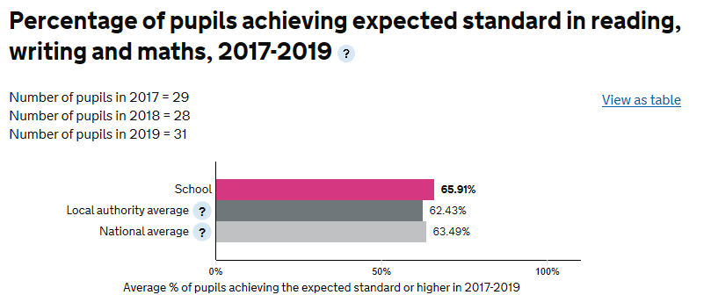
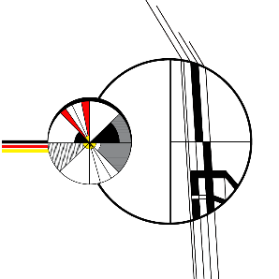
GLD
71%
67%
65%

Improvement Focus 1 |  | - Improve the proportion of HA readers across the whole school with particular emphasis on Upper KS2 leading to improved outcomes for HPA pupils in reading by the end of KS2. |  |  |  |  |  |  | Documents to support evaluation and shared with Governors
Success criteria: |  | By December | - Data Drop 1 shows that the majority of HPA are working within the blue band for attainment and progress remains steady.  - Observations and other monitoring shows that pupils in this group are being extended and encouraged to think more deeply about responses.  - Interventions are in place where required to ensure these pupils remain on track.
 |  | By April | - Data Drop 2 shows that all HPA pupils are working within the blue band and are maintaining progress against the most demanding targets.
 |  | By July | - Data Drop 3 shows that HA groups are equal to in number or exceed prior key point percentages.  - KS2 SATS show that 100% of HPA achieve a scaled score of 110+  - In KS1 the majority of HPA achieve a scaled score of 100+
No. | Action |  |  | Lead Person | Dates | Monitored by | Method of Monitoring | Resource Finance
Autumn term
1 | Inset on Reading Strategies and Focus |  |  | TB | 16th Sept | AR | Inset: Feedback sheets and subsequent monitoring | £500
 | Extended Reader Group for HPA |  |  | AR | 26th Sept – July | AR | Books and SEESAW | £1000
 | Inference Training for KS2 Staff |  |  | TB | 17TH Sept | AR | Feedback Sheets/Delivery Records | £1000
 | Data Drop 1 Analysis |  |  | CB | 2/12/19 | AR | Assessment Portfolio | £220
Spring Term
 | Revisit Ket Strategies and Share PALS work |  |  | TB | Feb 2020 | AR | Inset feedback. | £500
 | Share Lesson Study Info and process for Y4 |  |  | TB | Feb 2020 | AR | Review Documentation | £800
 | Data Drop 2 |  |  | CB | Apr 2020 | AR | Assessment Portfolio | £220
Summer Term
 | Data Drop 3 Analysis |  |  | CB | 2/12/19 | AR | Assessment Portfolio | £220
Shared (SLT and Governors) evaluation of success criteria:

Impact of actions in meeting success criteria

Improvement Focus 2 |  | Disadvantaged pupils make progress in writing in line with or better than their peers throughout school, leading to improved writing outcomes in KS2 SATs for disadvantaged pupils. |  |  |  |  |  |  | Documents to support evaluation and shared with Governors
Success criteria: |  | By December | Data Drop One Shows Disadvantaged pupils making progress better then peers in writing  Moderations show that Disadvantaged writers are working towards the expected standard  Insets on Writing have been delivered to support staff development  External CPD accessed by Writing Lead and disseminated to staff.  Staff requirements relating to CPD mapped and put in place. |  |  |  |  |  | Project Read Governor Feedback  Interview Records  Website and Social Media records  Assessment data  Headteacher Reports
 |  | By April | - Data Drop 2 shows Disadvantaged attainment is broadly in line with their peers  - Interventions in place to support struggling pupils  - Moderation shows that effective teaching strategies are having an impact on disadvantaged writers
 |  | By July | - Data Drop 3 shows that all disadvantaged pupils have made better than expected progress sin writing for the year and exceptions to this are evaluated, analysed and reflected upon with action plans and possible SEN plans in place.
No. | Action |  |  | Lead Person | Dates | Monitored by | Method of Monitoring | Resource Finance
Autumn term 2018

 | Writing Moderation |  |  | JG | Oct 2019 | AR | Meeting Evaluation | £200
 | Talk for Writing Training |  |  | JG/CA | Oct 2019 | AR | Inset to Staff | £500
 | Learning Walks |  |  | AR | Sept/Oct 2019 | AR | Monitoring Portfolio | £300
 | Teaching observations |  |  | AR | Sept/Oct 2019 | AR/Govs | Monitoring Portfolio | £300
 | Cluster Moderations
 | Data Drop 1 Analysis |  |  | CB | 2/12/19 | AR | Assessment Portfolio | £220
Spring Term 2019

 | Writing Moderation |  |  | JG | Oct 2019 | AR | Meeting Evaluation | £200
 | Learning Walks |  |  | TB | Sept/Oct 2019 | AR | Monitoring Portfolio | £300
 | Cluster Moderations
 | Data Drop 2 Analysis |  |  | CB | 2/12/19 | AR | Assessment Portfolio | £220
Summer Term 2019

 | Writing Moderation |  |  | JG | Oct 2019 | AR | Meeting Evaluation | £200
 | Cluster Moderations
 | Data Drop 3 Analysis |  |  | CB | 2/12/19 | AR | Assessment Portfolio | £220
Shared (SLT and Governors) evaluation of success criteria:

Impact of actions in meeting success criteria

Improvement Focus 3 |  | - Subject leaders to track and report on data and trends in non-core subjects leading to improvements in their understanding of their subjects and its place in the wider curriculum. |  |  |  |  |  |  | Documents to support evaluation and shared with Governors
Success criteria: |  | By December | - Assessments inputted on SEESAW and reported on by leaders  - Feedback to staff on trends to inform future planning  - Curriculum reviewed in line with findings and responded to by SLT.  - All curriculum leaders can discuss how assessment checks the effectiveness of the curriculum  - All curriculum leads have evaluated their action plan and reflected on sequencing arrangements.  - Staff discussion and review modifies aspects of the curriculum for the Spring Term, including peer review and collaborative planning. |  |  |  |  |  | Feedback books  SIP  SEF  Teacher Profile  SEN Report  PP Report  Monitoring Report  Headteacher Reports
 |  | By April | - Progress from initial assessments is good and improvement is seen in all areas.  - Staff feedback on resources required and trends in their teaching based on the data.  - Curriculum approach is reviewed and weaknesses identified for the summer term.
 |  | By July | - Full curriculum review led by subject leaders specific to their areas and in response to the data.  - Staff skills analysed and used to inform CPD for following year.
No. | Action |  |  | Lead Person | Dates | Monitored by | Method of Monitoring | Resource Finance
Autumn term 20

 | Curriculum Review |  |  | TB | Dec 2019 | AR | Curriculum Lead Folder
 | Action Plans reviewed and Submitted |  |  | TB | Oct 2019 | AR | Curriculum Records
 | Pupil Interviews on Curriculum and Subjects |  |  | TB | Nov 2019 | AR | CPD File
 | Staff Skilsl Audit |  |  | TB | Oct 2019 | AR | CPD File
 | Data Drop 1 Analysis |  |  | CB | 2/12/19 | AR | Assessment Portfolio | £220
Spring Term 20

 | Curriculum Review 2
 | Data Drop 2 Analysis |  |  | CB | 2/12/19 | AR | Assessment Portfolio | £220
Summer Term 20

 | Data Drop 3 Analysis |  |  | CB | 2/12/19 | AR | Assessment Portfolio | £220
Shared (SLT and Governors) evaluation of success criteria:

Impact of actions in meeting success criteria

