Fairmeadows Foundation Primary School
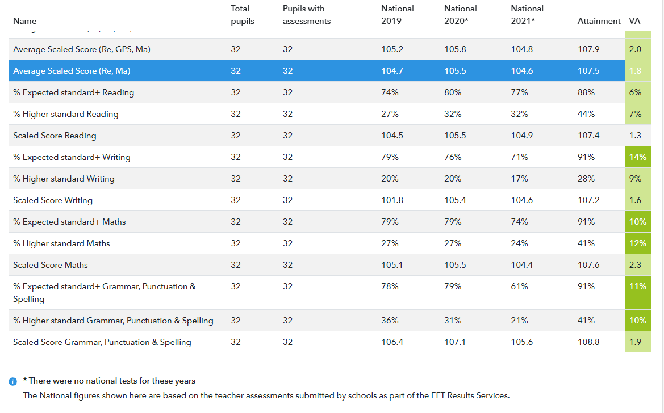
2021 End of Key Stage 2 Results – Internal Teacher Assessment

The assessment data shown here is internally moderated teacher assessment combined with past SATs paper results. The outcomes show that this group did well despite the disruption of the past two years and made good progress. They are a group with higher prior attainment and engaged more readily with home learning in the summer of 2020 and winter of 2021 better than any other year group. The results are a credit to them, their teachers and the parents.

