
Fairmeadows Foundation Primary School




Forest School Handbook
2023-2024

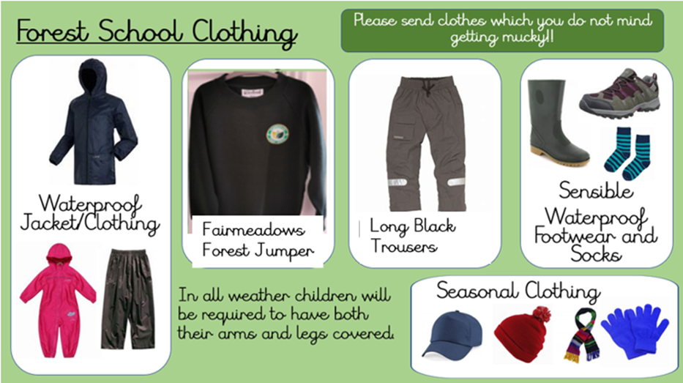

Contents
What is Forest School? | 1
Forest School at Fairmeadows Foundation Primary School  - Aim  - Provision | 2
What happens at Forest School? | 3
What are the benefits to Forest School? | 4
Fairmeadows Forest School | 5
Forest School Session  - Appropriate clothing  - Walking to site  - Forest school rules  - Activities, skills and techniques  - Leaving the site  - Additional session equipment | 6-8
Forest School Conduct  - Woodland Site  - Toileting  - Boundaries  - Fire Circle | 9
Forest School Activities Conduct  - Tools - Eating and drinking  - Fire - Climbing  - Sticks and stones - String and rope  - Digging | 10
Emergency Action Plan | 11
Fire Policies and Procedures | 12-13
Kelly Kettle | 14
Knots and Lashings | 15
Forest School Risk Assessments  - Site risk assessment  - Daily site risk assessment  - Activity risk assessment  - School risk assessment  - Template site check | 16-24
Letter to Parents | 25
Forest School Equipment | 26

What is Forest School?

Forest School is an inspirational process that offers ALL learners regular opportunities to achieve and develop confidence and self-esteem through hands-on learning experiences in a woodland or natural environment with trees. Forest School is a specialised learning approach that sits within and complements the wider context of outdoor and woodland education. The ethos is shared by thousands of trained practitioners across the UK and beyond. Its roots reach back to early years pioneers in outdoor learning and across the sea to Scandinavia.
At Forest School all participants are viewed as:
- equal, unique and valuable
- competent to explore & discover
- entitled to experience appropriate risk and challenge
- entitled to choose, and to initiate and drive their own learning and development
- entitled to experience regular success
- entitled to develop positive relationships with themselves and other people
- entitled to develop a strong, positive relationship with their natural world

This learner-centred approach interweaves with the ever-changing moods and marvels, potential and challenges of the natural world through the seasons to fill every Forest School session and programme with discovery and difference. Yet each programme does also share a common set of principles, aimed at ensuring that all learners experience the cumulative and lasting benefits that quality Forest School offers.

Principles of Forest School
These principles were first articulated by the Forest School Community in 2002. They were reviewed in 2011 and sent out for a 5-month consultation to Forest School networks and practitioners in all UK nations. They were published on the Institute for Outdoor Learning Forest School SIG page in Feb 2012, and in the minutes of the GB trainers’ network.
- FS is a long-term process of regular sessions, rather than a one-off or infrequent visits; the cycle of planning, observation, adaptation and review links each session.
- FS takes place in a woodland or natural environment to support the development of a relationship between the learner and the natural world.
- FS uses a range of learner-centred processes to create a community for being, development and learning.
- FS aims to promote the holistic development of all those involved, fostering resilient, confident, independent and creative learners.
- FS offers learners the opportunity to take supported risks appropriate to the environment and to themselves.
- FS is run by qualified Forest School practitioners who continuously maintain and develop their professional practice.
This ethos creates learning communities where deep-level learning and progression are the norm.
(What is Forest School? extracted from The Forest School Association. www.forestschoolassociation.org)

Forest School at Fairmeadows Foundation Primary School
We aim to provide children with a natural learning environment, that offers opportunities and experiences, along with the time and space to develop and learn through hands-on experiences, risk taking and choice to initiate their own learning.
Fairmeadows Forest School Aim 2020

At Fairmeadows Foundation Primary School the focus of our Forest Schools is to engage and provide children with a unique educational experience with opportunities for children to develop and succeed through hands-on experiences in a natural woodland environment.
Forest School is a process which will be offered to children throughout the year, in almost all weathers. They will develop practical skills, collaborative working skills, self esteem and confidence through enjoyable and unique opportunities that can be transferred to not only their learning within the classroom, but provide them with lifelong skills and understanding of the natural world.
Provision
Fairmeadows Forest School aims to offer every child the opportunity of a regular Forest School learning programme over their school year with our qualified Forest School Practitioner. In addition the Forest School provision, can be used for outdoor cross curricular learning and children are able to apply their new learning within the classroom

What happens at Forest School?
Children will engage in motivating and achievable tasks and activities throughout the year and in almost all weathers, with the appropriate footwear and clothing. Children will work with tools, play, learn and begin to understand the boundaries of behaviour, both physical and social They will grow in confidence, self- esteem and motivation whilst developing an understanding of the natural world.
All sessions will be planned and led by led by our Forest School practitioner, Miss Peace and supported by class teaching staff. Each session will last approximately an hour, activities will be dependent upon group size, capabilities and knowledge of Forest Schools, although as the weeks progress children’s confidence, skills and abilities will grow and sessions will begin to follow the Forest School principles of encouraging participant=led learning, allowing more responsibility and freedom for children to initiate their own and the groups direction of learning.
The Forest Schools setting at Fairmeadows will primarily use natural materials to encourage children’s investigation, creativity and imagination. Activities may include:
- Woodworking and use of tools
- Shelter building
- Fire building
- Climbing and balancing
- Creating wildlife habitats and homes
- Collecting, sorting and identifying natural resources
- Using knots
- Team games and activities
The activities will sometimes be used to support curriculum-based learning and can link to a number of subjects including Art, English, Maths and Science. Therefore, enhancing children’s learning in a unique manner and fitting the active learning approach used at Fairmeadows.
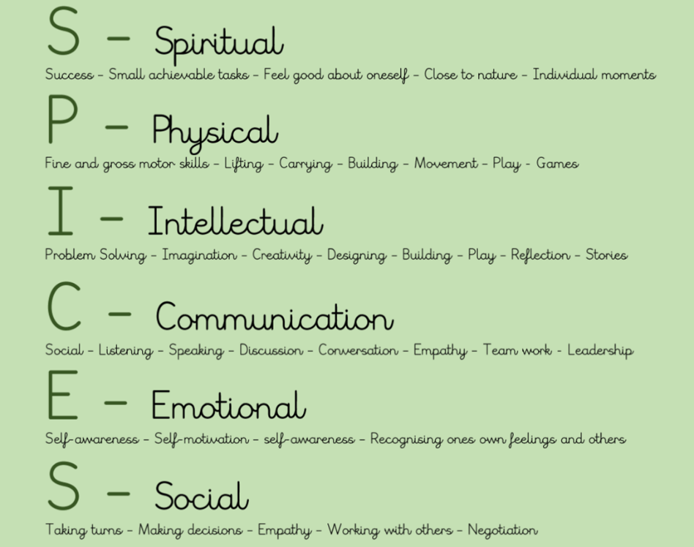
SPICES
Holistic is defined as considering the person as a whole, taking into account mental, social and physical factors of the person. The Forest School approach incorporates and supports the holistic development through it’s the environment and ethos in which it is delivered. Every child is unique and at any one time you can be delivering a session that could be meeting any number of needs for a variety of children. Therefore using SPICES can support the planning and evaluation of sessions to promote and recognise holistic development.
hildren.

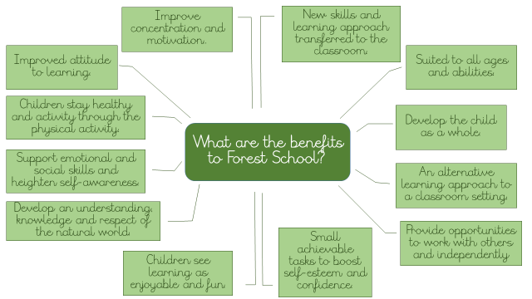
Fairmeadows Forest School

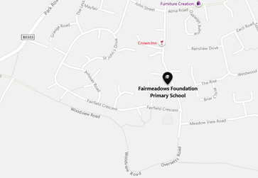
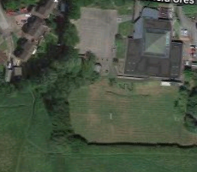

Fairmeadows Forest School is within school grounds and is not accessible to the public, however due to the perimeters of the site being close to public areas the site is checked before each session to ensure the safety of the participants.
The Forest School takes place in a small wooded area on the school grounds and is made up of a variety of flora and fauna which requires regular woodland maintenance to ensure the preservation of areas and to encourage continued growth of what is a beautiful natural area for the school.
Children will be actively involved in the maintenance of the Forest School site, so as to understand how they can reduce their impact on the natural environment. Such activities will include creating walkways and areas to allow for growth and wildlife to thrive, understanding why and how we can respect the natural environment and the wildlife within and learning methods of maintaining, replacing and preserving each time we access the site.

Forest School Session
Fairmeadows Forest School sessions will be held for each year group and each will follow a routine.
Appropriate Clothing
There is no such thing as bad weather with Forest School, enjoying the outdoors requires those participating to wear appropriate clothing in order to gain the most benefit and enjoy the activities available. Children will come to school dressed in their PE kit, consisting of the PE logo sweatshirt and long black jogging bottoms, they may bring additional layers and can get changed into these before each session and will go home at the end of the school day dressed in their Forest School kit.

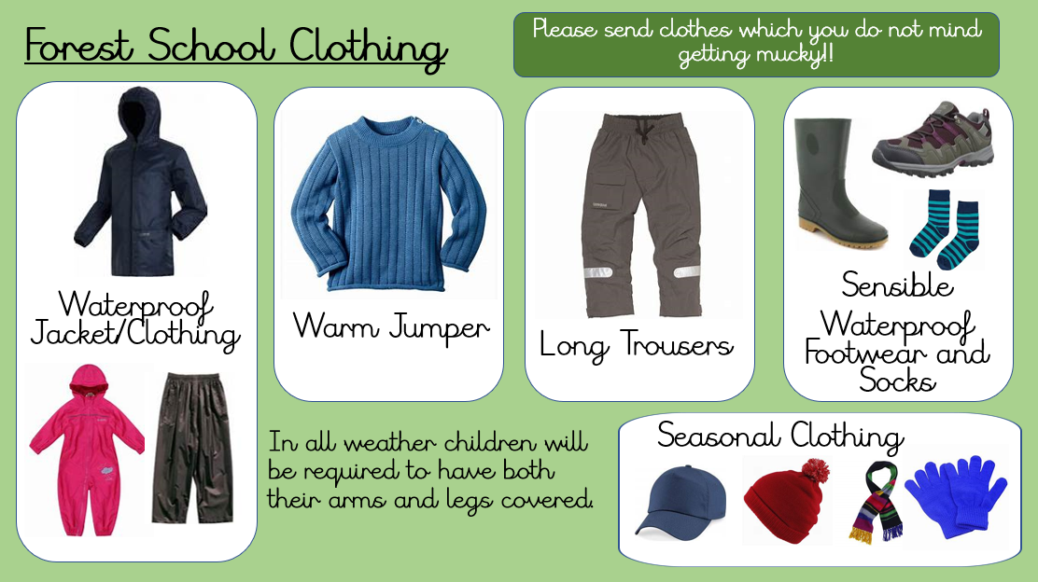
Fairmeadows
PE KIT JUMPER
PE black jogging bottoms
Walking to Site
Once dressed children will be led to the Forest School site. This will be in single file with an adult at the front and back. Children will be seated in the fire circle area, which is the central focal point and main area at the start and end of sessions. Any resources which are required for the session will be collected from the storage area in preparation for the activities planned and those which the children choose to undertake themselves.
Forest School Rules
The first sessions will be spent learning and understanding the Forest School rules, routines and the site layout. After this, before each session children will be reminded and discuss the Forest School rules and routines, these may be weather dependent and children will recognise rules based on the current conditions. The activities for the session will be discussed, allowing children to be aware of what will be going on within the site, as some areas may be restricted and additional rules to be adhered to.



Forest School Session Rules

Walk carefully around the site, running can cause slips, trips and falls!

Don’t pick it! Don’t lick it! Don’t kick it!

If it’s bigger than you, it takes two!

Stay within the boundaries of the site.

Enter and exit the fire circle through the correct areas.

Activities, Skills and Techniques.
Each Forest School session will provide a variety of options to the group, this may include a small group undertaking a specific skill such as tools or fire led by the Forest School Practitioner, a Forest craft activity and the option for children to undertake their own exploration and learning with access to resources to support them. One of the principles of Forest School learning is a learner centred approach, therefore allowing them choice with their learning. However, we aim to provide each group with the opportunity to learn new skills and techniques, which will progress and develop over their time at Fairmeadows.
Leaving the Site
The session will end in the fire circle area, this time allows children to share what they did and enjoyed, whilst also allowing them time to share anything they would like to do in the next session. All resources and activities will be cleared from the site, so as to leave the area in the natural state that they would have found it.

Additional Session Equipment
In addition to the tools and materials required for the activities, the Forest School Practitioner will have an emergency bag at each session. Contents will vary according to the weather and activities planned, A basic first aid kit will be carried to deal with minor incidents, however the school and its medical room is easily accessible for the site should it be required.
Basic First Aid Kit | Pillow | Children’s Medical Information
Emergency Whistle | Blanket | Individual Medication  (If required)

Forest School Conduct

Woodland Site
Fairmeadows benefits from our own onsite woodland area, which at the start and end of a session will be entered and excited respectfully with children following and understanding the Forest School expectations and rules which will be discussed at the start of each session.
During Forest School sessions the children will take part in activities and experiences which allow them to investigate and explore the natural environment, during this time they will also be respecting how we are sharing the area as the Woodland environment is home to wildlife, animals and plants.
Should any unnatural items be found onsite, children are made aware to not touch and tell an adult who will remove from the area.
On leaving the site, any items brought in will be taken, tools and equipment will be checked and counted back in, shelters taken down and the site left in a natural state as possible.

Toileting
Before the session children will be asked to go to the toilet. During a session if a child needs the toilet, the Key Stage 1 toilet area door will be left open and an adult will supervise children, Key Stage 1 children will use the KS1 toilets and key stage 2 walk through to their area.

Fire Circle
The fire circle is in the main area of the Forest School, it is the starting and ending point of a session and where children return to when called. Seating will be available and placed 2.0m away from the 1m square fire pit area.
- Children cannot enter without adult permission.
- No running through or past the fire circle.
- Only items placed or carried by an adult can be in the fircle circle area.
- There are 3 entrances/exits which must be used to move around the fire area. Even if there is an unlit fire children must go outside the fire circle to move to another seat.

Boundaries
Children are made aware of the exploration boundaries of the woodland area, our onsite facility benefits from clear fencing boundaries which provides a self contained area for the Forest School provision. If children need to return to the fire circle area they will be taught to respond to the ‘1,2,3 where are you?’ call from adults, with ‘1,2,3, coming to you’ as they make their way back towards the circle.

Forest School Activities Conduct
Tools
The Senior Leadership Team will be made aware if a session involves the use of tools. Any tools used during activities will have their own code for correct use, for many this includes a ‘tool talk’ to explain the correct use, handling and personal protective equipment that is to be used. Any tool activity will be with a qualified adult.

Fire
The Senior Leadership Team will be made aware if a session involves the use of fire. When fire is being used for an activity, all fire safety equipment must be close to hand, Both children participating and not participating in the activity will be briefed on the fire safety procedure, to understand their role. All adults will be briefed on their role. All fires will be lit within the fire pit and no lit fire will be left unattended.

Sticks and Stones
Children are encouraged to use sticks and stones, they are not for throwing. Any stick picked up must be smaller than them, if larger they will seek assistance from another person and with one at each end they will drag or carry it. Only sticks that have fallen and are on the ground can be used and not pulled from the trees. Children are to be aware when putting stones down if it is safe and what is beneath, Children will also be made aware that moving natural items around the site could disrupt animals homes so to be cautious. When moving materials depending on the size children will be shown the safe lifting position or will use a drag. roll or lift technique with support where needed.

Digging
Digging is not permitted anywhere in the Woodland area, small sticks and fingers can be used to create small divots for activities such as bug hunting, but no deep holes are to be made.

Eating & Drinking
Children will be made aware of the ‘do not pick it or lick it’ rule and to avoid putting their hands near their faces or in their mouths when they are in the Woodland area. Children will only be able to eat and drink what has been provided for them after they have cleaned their hands using wipes or handwashing facilities onsite or within the school building.

Climbing
There will be an allocated tree for climbing in the Woodland area. A visual check of both the ground area around the tree and branches will be checked to ensure it is safe to climb When climbing the tree an adult must be present and near enough to support and assist where needed, children are permitted explore to a maximum of 1.5m.

String and Rope
The use of string and rope are permitted to be used by children, for activities such as shelter building and tying and attaching items together. This will be monitored by an adult to ensure the safe use and to model knot techniques.

Emergency Action Plan
Before taking part in Forest School sessions, all staff will be informed of the procedures to take in the event of an emergency.
- Secure the group members and keep together in a safe area.
If the whistle is blown all children and site users will immediately return to the fire circle and adults onsite will ensure children are all gathered in the area together. The whistle being blown will alert the main school to an emergency,
- Assess the incident and prioritise actions/injuries.
During a Forest School session there must be a qualified Forest School leader present and at least one other member of staff. It is important to maintain the safety of not just the injured person, but all others on the site at the time.
- Inform the School,
The main school will be alerted of the emergency, if the whistle has not already done so. At this stage calling for an ambulance if necessary.
- Offer First-Aid
During a Forest School session there must be at least 1 member of staff qualified in First Aid, or the qualified Forest School Leader who has completed Outdoor First Aid training.
- Keep casualty safe and warm
Assess the area and injuries as reasonably possible. In the Emergency Kit Bag there is a First Aid Kit and Welfare kit.
- Check the rest of the group, Make sure they are comfortable and safe.
A staff member will remain with the group, until other adults arrive to the scene and support.

Essential Items:
- Emerhgency Kit Bag
- Emergency Outdoor First Aid Kit
- Emergency Whistle
- Welfare Kit (pillow, blanket)
- Medication for individuals
- Walkie Talkie

Fire Policies and Procedures
At times the Forest School experience will involve risky activities which will enhance children’s learning and development. The exposure and encounters with risk allow children to develop strategies to cope whilst discovering and participating in real experiences. The activities are risk assessed and over a period of time sessions are planned to provide children with higher risk opportunities as they develop more responsibility, understanding and knowledge of the Forest School provision.

Fairmeadows Forest School will provide experiences to children to allow them to enjoy the outdoors and nature, this will include learning about the safe use of fire and how to make fires including the use of Kelly kettles. During their time at Fairmeadows children may also get the opportunity to light their own fires. Our Forest School Leader is skilled and practiced in fire-building and management, therefore fire lighting will only take place under their strict supervision on a one to one adult to child ratio.

This policy provides guidelines for safe practice when using fire as an activity as part of the Forest School experience.

When having a fire:
-Flame retardant gauntlet gloves
-Fire Blanket
-Bucket of water
-Cotton wool
-Steel and Flint

- Before a fire is lit, a visual risk assessment will be carried out of the site.
- Fires and Kelly Kettles, must only be lit within the fire circle area.
- Fires will only be lit in the fire circle by a trained Forest School Leader and there will always be a trained adult present when a fire is lit. A fire will never be left unattended, even with hot embers.
- The fire pit within the fire circle will be built and the ground assessed to ensure it is not built or lit on a flammable surface.
- Surrounding the fire will be a 1 metre square of double logs to provide a secure barrier to the lit fire. These logs will be secured by pegs.
- The site and weather conditions will be assessed prior to lighting a fire, they not be lit on really windy days and overhanging branches will be maintained.
- An adequate water supply must be available close to the fire pit, with enough water available to extinguish the fire if it is required in an emergency,
- A fire blanket must be onsite during fire sessions, this will be used to wrap around someone should their clothes become alight.
- A supply of gauntlets will be close to the fire, to ensure safe handling of hot items.

Fire procedure

- If in the event a fire cannot be put out safely and quickly by the Forest School Leader, a whistle will be blown repeatedly to alert the group.
- Once gathered together, a head count will be conducted and the area will be evacuated to the fire meeting point on the school playground.
- One member of staff will alert SLT in the main school with an instruction to call the emergency services.
- Someone will stand at the school entrance to direct the emergency services.

Fire Safety

- Children will be given information about fire safety before a fire session, with the opportunity for children to ask questions.
- The rules of a Forest School fire will be discussed and demonstrated at the fire circle, explaining the rules and expectations of the session to the children.
- When a fire is lit, children will remain seated in the fire circle area, with no more than 2 adults and children next to the fire.
- To remain stable next to the fire adults and children will position themselves on one knee (the respect position).
- Any long hair must be tied back and scarves or hanging items must be removed.

This policy and risk assessment will be annually reviewed. However, earlier changes may be made based on new research and government guidelines.

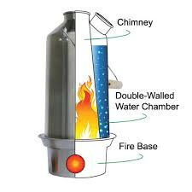
Kelly Kettle

A Kelly kettle will be used to heat water, under the
supervision of the Forest School Leader. The use of a
Kelly Kettle requires a fire to be lit and therefore fire
procedures need to be followed.

Using a Kelly Kettle.
- Fill the kettle with water – to approximately 15mm below the water spout.

- Do not over fill as the water could boil over.
- The bung must be removed when heating water and never be left in the kettle, this could cause the kettle to explode as the water expands into steam.

- The fire base of the Kelly Kettle must be placed on a flat, level ground.

- Begin to make a small fire in the base of the bowl.
- Use any form of tinder (dried grass/birch bark)

- The fire can either be lit in the base and then placing the kettle over the fire, or you can firstly place the kettle on the base and then light the fire through the small hole (this option provides more protection on a wet/windy day).

- The hole of the fire bowl should be positioned into the wind.

- To continue to fuel the fire, the chimney can be used to drop in small materials such as twigs.
- Make sure your additional fuel is close to the fire circle, along with fire safety equipment and resources.
- Do not stand or look directly over the Kelly Kettle.
- Once the water has boiled, use two hands to grip the wire handle and remove from the base.

- The bung can be placed in the hole to stop any debris or bugs entering the water.
- The spare water can be used to make sure the fire is out in the base of the kettle.

Knots and Lashings
Knots and lashings form part of the learning with Forest School, the ability to tie successfully one item to another is a skill which is both useful for the Forest School setting but also a life skill.
The process of teaching and learning knots will be a progressive process in the Fairmeadows Forest School as there are a number of knots ranging from simple to more complex which will be taught to the children.
The Level 3 Forest School Leader will be responsible for ensuring activities which involve knots and lashings are risk assessed and follow the appropriate policies and procedures.
- Any ropes used during a Forest School session will be checked by the Forest School Leader.
- The safe use of ropes will be checked before use, including knots tied.
- Ropes and knots will be constantly monitored.
- During rope activities, children will be supervised by a competent adult.

This policy and risk assessment will be annually reviewed. However, earlier changes may be made based on new research and government guidelines.

Forest School Risk Assessments

Site Risk Assessment
The Forest School Leader will complete a site risk assessment before the site is used. The site risk assessment will be approved by Mr A Reeves (Headteacher) and updated where there are any updates or changes that are either permanent or due to seasonal changes if they have not already been logged on the daily site assessment (see below).

Daily Site Risk Assessment
The Fairmeadows Forest School learning site will have a site risk assessment (safety sweep) before the area is used to ensure there are no changes on the site which could cause harm.. The inspection will be extra cautious following bad weather or high winds. The Forest School leader will lead the check using the risk assessments, anything that is needed to be done to make the site safe (such as removal of any hazards restrict or mark off unsafe areas) and consider circumstances where it is not appropriate for a Forest School Session to go ahead, in this instance Forest School based activities will take place indoors.
Details from site checks will be logged below, including any amendments and signed off by the Forest School leader.
Date | Hazards Identified  (Canopy at all levels/Slips & Trips/Vandalism &Litter/Weather/Water/Boundaries) | Action Taken | Signature

Activity risk assessment
When planning for Forest School based activities, any hazards that may be associated with that activity will be considered, particualrly those that are a risk of causing harm. Such activities will have a risk assessment and suitable control measures taken to control and minimise the risk to the particpants. The nature of Forest Schools may involve new activities being created during a session and reasonable steps will be made to ensure the activity is safe and a new activity risk assessment will be created for the activity after the session.

Fairmeadows Forest School - Site Check
The Fairmeadows Forest School learning site will have a site risk assessment (safety sweep) before the area is used to ensure there are no changes on the site which could cause harm.. The inspection will be extra cautious following bad weather or high winds. The Forest School leader will lead the check using the risk assessments, anything that is needed to be done to make the site safe (such as removal of any hazards restrict or mark off unsafe areas) and consider circumstances where it is not appropriate for a Forest School Session to go ahead.
Details from site checks will be logged below, including any amendments and signed off by the Forest School leader.
Date | Hazards Identified  (Canopy at all levels/Slips & Trips/Vandalism &Litter/Weather/Water/Boundaries) | Action Taken | Signature

Date | Hazards Identified  (Canopy at all levels/Slips & Trips/Vandalism &Litter/Weather/Water/Boundaries) | Action Taken | Signature
Fairmeadows Forest School - Site Check

Forest School Letter to Parents
Dear Parents/Carers
Fairmeadows Foundation Primary School is pleased to be able to offer a ‘Forest School Experience’ to children from Reception to Year 6 in the forest area within the school grounds and led by our qualified Forest School Leader, Miss Peace.
Your child will be participating in a once a week Forest School session for 6 weeks of the school year. Please ensure your child is wearing their Forest School uniform (PE KIT) on their allocated Forest School learning day, you may provide additional clothing and layers which your child can get changed into before their session.
Forest School is an inspirational process that offers learners an experience to achieve and develop confidence and self-esteem through hands-on risk assessed learning experiences in our onsite natural woodland area. Forest School is a specialised learning approach that sits within and complements the wider context of outdoor and woodland education.

Children will engage in motivating and achievable tasks and activities throughout the year and in almost all weathers, with the appropriate footwear and clothing. Activities can include children working with tools, natural art, using knots, fire lighting and shelter building. Children will play, learn and begin to understand the boundaries of behaviour, both physical and social They will grow in confidence, self- esteem and motivation whilst developing an understanding of the natural world., whilst under the supervision of adults.
This is a wonderful opportunity for the children at Fairmeadows to learn outdoors, then apply their new learning within the classroom. All children will automatically take part in the learning experience, unless you contact the school directly. For more information please read the Forest School handbook available on our school website.

